

Project Campus™
“A Unified Academic Social Platform”

Project By
Ayham Al Sayed Ibrahem Al Sharif Laith Abu Arrah

This project was submitted in partial fulfillment of the requirements for the Bachelor's degree in Computer Science.
2025 – 2026
Contents

Abstract 6
1. Introduction 7
1.1 Introduction 8
1.2 Problem Statement 8
1.3 Project Objectives 8
1.3.1 Main Objectives 8
1.3.2 Sub-Objectives 9
1.4 Project Benefits 9
1.5 Chapter Conclusion 10
2. Methodology 11
2.1 Introduction 12
2.2 Project Methodology 12
2.3 Project Management 13
2.3.1 Roles and Responsibilities 13
2.3.2 Risk Management 13
2.4 Project Workflow 14
2.5 Project Constraints 15
2.5.1 Technical Constraints 15
2.5.2 Security Constraints 15
2.5.3 Financial Constraints 15
2.5.4 Operational Constraints 15
2.5.5 Social and User-Related Constraints 16
2.6 Chapter Conclusion 16
3. System Analysis 17
3.1 Introduction 18
3.2 The Proposed System 18
3.3 Actors and Roles 19
3.4 Role-Based Access Control 20
3.5 Membership and Verification System 22
3.5.1 User Verification 22
3.5.2 Subscription Plans 23
3.5.3 Promotions 24
3.6 Functional Requirements 24
3.6.1 Account and Profile Management 25
3.6.2 Content and Feed 25
3.6.3 Communities 25
3.6.4 Messaging 25
3.6.5 University Pages 26
3.6.6 Events 26
3.6.7 Subscriptions and Promotions 26
3.6.8 Notifications and Settings 26
3.6.9 Safety and Moderation 26
3.7 Non-Functional Requirements 27
3.8 Feasibility Study 27
3.8.1 Technical Feasibility 27
3.8.2 Economic Feasibility 28
3.8.3 Operational Feasibility 29
3.8.4 Legal Feasibility 29
3.9 Use Case Diagrams 29
3.9.1 Student 30
3.9.2 Instructor 31
3.9.3 Page 32
3.9.4 University 33
3.9.5 Admin 34
3.10 Sequence Diagrams 35
3.10.1 User Registration 35
3.10.2 Create Post 36
3.10.3 Send Message 37
3.10.4 Join Community 38
3.10.5 Community Creation Request 39
3.10.6 Subscription Checkout 40
3.10.7 Publish Announcement 41
3.11 Entity Relationship Diagram 42
3.12 Database Tables 43
3.13 Chapter Conclusion 45
4. System Implementation 46
4.1 Introduction 47
4.2 Implementation Approach 47
4.3 System Architecture 48
4.4 User Interface 49
4.4.1 Landing page and registration page 50
4.4.2 Home Feed 51
4.4.3 Profiles 52
4.4.4 Communities 54
4.4.5 Chats and Group Chats 55
4.4.6 University Page 56
4.4.7 Events 57
4.4.8 Pages, Subscriptions and Promotions 58
4.4.9 Pages Section 59
4.5 Chapter Conclusion 60
5. Conclusion and Future-Work 61
5.1 Conclusion 62
5.2 Challenges and Obstacles 62
5.3 Future-Work and Recommendations 63

Figures

Figure ‎2.1 Project Timeline 14
Figure ‎3.1 Student Use Case Diagram 30
Figure ‎3.2 Instructor Use Case Diagram 31
Figure ‎3.3 Page Use Case Diagram 32
Figure ‎3.4 University Use Case Diagram 33
Figure ‎3.5 Admin Use Case Diagram 34
Figure ‎3.6 User Registration Sequence Diagram 35
Figure ‎3.7 Create Post Sequence Diagram 36
Figure ‎3.8 Send Message Sequence Diagram 37
Figure ‎3.9 Join Community Sequence Diagram 38
Figure ‎3.10 Community Creation Request Sequence Diagram 39
Figure ‎3.11 Subscription Checkout Sequence Diagram 40
Figure ‎3.12 Publish Announcement Sequence Diagram 41
Figure ‎3.13 Entity Relationship Diagram 42
Figure ‎4.1 System Architecture 48
Figure ‎4.2 Landing page 50
Figure ‎4.3 Registration page 50
Figure ‎4.4 Home page 51
Figure ‎4.5 Personal profile 52
Figure ‎4.6 Student Profile 52
Figure ‎4.7 Instructor Profile 53
Figure ‎4.8 Page Profile 53
Figure ‎4.9 Communities Explore 54
Figure ‎4.10 Community Feed 54
Figure ‎4.11 Chats Section 55
Figure ‎4.12 Academic Group Chat 55
Figure ‎4.13 University Section 56
Figure ‎4.14 University Section Management 56
Figure ‎4.15 Events Section (Students and Instructors view) 57
Figure ‎4.16 Events Section (Universities and Pages view) 57
Figure ‎4.17 Page Personal Profile 58
Figure ‎4.18 Subscriptions 58
Figure ‎4.19 Community Promotion 59
Figure ‎4.20 Pages Section 59

Tables

Table ‎3.1 Actors and their roles 19
Table ‎3.2 Role-based access control 20
Table ‎3.3 Page subscription plans 23
Table ‎3.4 Promotion pricing 24
Table ‎3.5 Estimated annual operating costs 28
Table ‎3.6 Projected first-year revenue 28
Table ‎3.7 Database Tables 43
Table ‎4.1 Component table 49

Abstract

Project Campus is a unified web-based academic social platform designed to centralize university communication and reduce reliance on fragmented informal channels such as WhatsApp and Facebook. The platform provides students, instructors, universities, and verified organizations with a structured digital environment for sharing academic information, official announcements, events, and community discussions through a single reliable system.

The platform promotes collaboration by connecting students from multiple universities within one integrated ecosystem, encouraging knowledge exchange and interaction across different academic communities. It also improves academic accessibility through dedicated university pages, faculty profiles, and organized communities that enable users to communicate, share content, and participate in academic and social activities more efficiently.

To ensure authenticity and trust, Project Campus incorporates a role-based access model supported by a verification and membership system. Universities receive verified institutional accounts, instructors register using their academic credentials, and businesses and organizations are onboarded by admins after direct contact before being granted an official presence on the platform. These mechanisms help maintain the credibility of published content while protecting the integrity of the academic community.

By integrating communication, collaboration, and verified information within a single platform, Project Campus aims to improve information accessibility, strengthen engagement among academic stakeholders, and provide a scalable foundation for enhancing the overall university experience.

Introduction

Introduction

Effective communication plays a vital role in the academic environment, influencing how students receive information and interact within their universities. Many students rely on informal platforms such as WhatsApp and Facebook for academic updates; however, these channels often lack structure, reliability, and academic focus.

Project Campus addresses this issue by providing a unified digital platform that centralizes academic communication. The system offers official announcements, university-specific pages, faculty profiles, and organized spaces for academic and social interaction, enabling more efficient and reliable engagement.

By reducing information fragmentation and improving accessibility, Project Campus aims to strengthen communication between students, instructors, and universities, ultimately enhancing student engagement and the overall academic experience.

Problem Statement

The absence of a unified communication system creates several interconnected problems. Important academic content is fragmented across multiple platforms, leading to misinformation and delayed updates. Students struggle to identify and connect with instructors due to the lack of centralized, verified academic profiles. Beyond a single campus, the fragmented environment limits students from different universities from exchanging experiences, collaborating, and building academic networks in any structured way.

Project Objectives

Main Objectives

- Establish a Unified and Reliable Academic Communication Platform: to design and implement a centralized digital platform that replaces fragmented communication channels and ensures accurate, verified, and timely academic information delivery for university students.

- Enhance Academic and Social Interaction Within the University Community: to improve communication, collaboration, and engagement between students, instructors, and academic communities through structured and organized digital interaction.

- Deliver a Secure, Scalable, and Future-Ready Digital System: to develop a modern, user-friendly platform supported by a robust technical architecture that ensures security, performance, and long-term expandability.

Sub-Objectives

- Consolidate scattered communication tools (e.g., WhatsApp, Facebook groups, informal networks) into a single integrated platform.

- Ensure accuracy, reliability, and centralization of academic information through verified, official university pages.

- Minimize information loss and fragmentation by providing a unified and real-time notification system for academic updates.

- Enhance academic communication between students and instructors through direct, structured interaction using verified instructor and university profiles.

- Create an organized social-academic digital ecosystem that supports student posts, discussions, community groups, and university-related activities.

- Improve the management and coordination of student activities and events to increase awareness, engagement, and participation.

- Promote collaboration and knowledge exchange across universities by enabling interaction between students from different academic institutions.

- Deliver a modern and intuitive user interface with clear onboarding guidance to ensure a smooth experience from the first login.

- Establish a strong foundation for future expansion and innovation.

Project Benefits

- Centralized and Reliable Information Access: students access all academic updates, announcements, and university news in one verified platform, reducing confusion, eliminating misinformation, and saving the effort of checking multiple sources.

- Improved Communication with Instructors: the platform provides a direct and structured way to reach instructors and academic staff through verified profiles, helping students get accurate answers quickly and improving overall academic coordination.

- Centralized Access to Important Updates: official announcements from universities and pages are published in one trusted place on the platform, so students no longer have to track updates scattered across informal sources like social media and messaging groups.
- Organized Academic and Social Balance: unlike informal platforms where academic updates are buried under unrelated content, Project Campus keeps academic information structured and prioritized while still offering dedicated spaces for communities, hobbies, and student discussions, separating the two without forcing students to leave the platform.

- Enhanced Engagement and Community Building: dedicated communities and discussion spaces encourage collaboration, knowledge exchange, and interaction among students from different universities.

- Organized Management of Activities and Events: universities, pages, and student clubs promote events and activities more efficiently, making participation easier and improving student involvement.

- Higher Credibility and Academic Trust: because content is published through official or verified channels, students can rely on the accuracy and legitimacy of the information they receive.

Chapter Conclusion

This chapter introduced Project Campus and the motivation behind it, highlighting the communication challenges university students face when relying on fragmented and informal channels. It defined the problem the project addresses, outlined the main and sub-objectives guiding its development, and presented the benefits the platform offers to students, instructors, universities, and businesses. Together, these establish the foundation and direction of the project. The following chapter presents the methodology adopted to plan, manage, and develop the system.

Methodology

Introduction

This chapter describes the approach followed to plan, manage, and develop Project Campus. It presents the development methodology adopted by the team, the way the project was managed and divided among members, the overall workflow across the project duration, and the constraints that shaped the scope and execution of the work.

Project Methodology

Project Campus is developed using the Agile methodology, which provides flexibility, iterative development, and continuous refinement throughout the project lifecycle. This approach suits a platform of this scale, where design and development progress in parallel and requirements are refined as the system takes shape.

- Requirements Gathering: the project begins by collecting and analyzing user needs based on the academic communication challenges students currently face. Functional and non-functional requirements are identified through observation, research, and problem analysis.

- Backlog: the gathered requirements are organized into a product backlog containing all features and tasks, prioritized according to their importance and impact. This gives the team a clear, ordered view of what the system must achieve.

- Sprint Planning: the work is divided into repeating development cycles known as sprints. At the start of each sprint, the team selects a set of backlog items based on priority, technical feasibility, and team capacity, with each sprint focused on delivering a complete and functional part of the system.

- Incremental Development: within each sprint, features are built and refined iteratively. Key activities include designing user interface components and user flows, implementing front-end and back-end functionality, integrating new features with existing modules, and maintaining scalability, performance, and consistency across the system.

- Testing: testing is carried out throughout development rather than being left to the end. This includes verifying individual components, ensuring correct communication between modules, and validating the usability and clarity of the interface, allowing issues to be identified and addressed early.

- Sprint Review: at the end of each sprint, the team reviews the completed work, evaluates progress against the sprint goal, and updates the product backlog accordingly, allowing the plan to adapt as the project evolves.

- Sprint Feedback: following each sprint, the team reflects on the process to identify what worked well, recognize challenges, and define improvements for the next cycle, supporting continuous enhancement of productivity, organization, and communication.

Project Management

The project followed a structured, Agile-based management approach to ensure steady progress, effective coordination, and alignment with the project's objectives within the available time. Responsibilities were distributed according to each member's strengths, while planning and risks were managed collaboratively throughout the development lifecycle.

Roles and Responsibilities

Responsibilities were distributed according to each member's strengths, with tasks assigned collaboratively based on the needs of each stage:

- Laith Abu Arrah: Idea owner. Responsible for project planning, the complete UI/UX design, the design of system features and workflows, and documentation.

- Ayham Al Sayed: Backend developer. Responsible for server-side logic, database design and management, and testing during development.

- Ibrahem Al Sharif: Frontend developer. Responsible for implementing the user interface and translating the conceptual designs into a responsive, functional front end.

Responsibilities were distributed but not rigidly fixed; members regularly assigned and shared tasks with one another based on what each stage of the project required. Coordination was maintained through continuous communication, shared task tracking, and regular meetings to review progress, align on priorities, and resolve issues.

Risk Management

Several risks were identified early and actively managed throughout the project:

- Schedule risk: because the project ran alongside full academic coursework, there was a risk of falling behind. This was managed by prioritizing essential features first and keeping the scope focused on a functional prototype.

- Workload distribution risk: with only three members covering design, frontend, backend, documentation, and testing, uneven workload could have created bottlenecks. This was managed through flexible task sharing and mutual support across roles.

- Technical risk: complex features such as real-time messaging and role-based access introduced a risk of integration problems. This was managed through a modular design and incremental integration, so issues surfaced early.

- Scope risk: as the platform grew, there was a continuous risk of expanding beyond what was achievable in the available time. This was managed by clearly separating prototype features from planned future work.

Project Workflow

The project was carried out over ten months across four phases: planning and requirements, UI/UX design, development, and testing and delivery. These phases overlapped rather than running one after another. UI/UX design continued through most of the project, so the interface was refined as features were built. Development began in the fourth month, after the requirements and initial designs were ready, while documentation continued from start to finish. The chart below shows the timeline and how tasks were distributed.

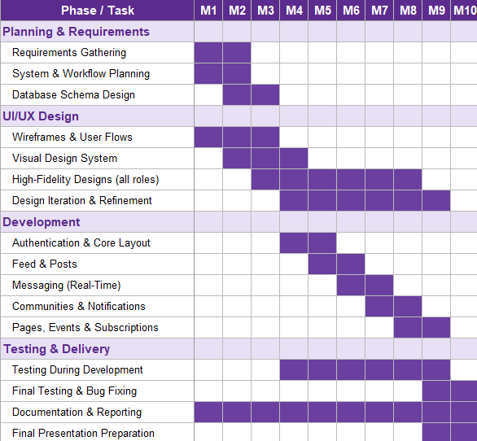

Figure ‎2.1 Project Timeline

Project Constraints

Technical Constraints

- Scalability: the platform must be designed with a flexible architecture capable of handling a growing number of users without sacrificing performance, which adds complexity to the system design.

- Real-Time Interactions: features such as instant notifications and messaging require real-time communication infrastructure, which influences technology choices and increases system complexity.

- Database Performance and Storage: the system must store and serve large amounts of data, posts, comments, media, and profiles while keeping queries fast and data secure, placing constraints on database design and optimization.

Security Constraints

- Protection of Personal and Academic Data: because the platform handles academic and personal information, it must apply secure authentication and data protection measures to prevent unauthorized access or breaches.

- Academic Email Verification: students register using their academic email address and confirm their identity through a verification code sent to that email, which constrains the registration flow to verified academic addresses.

Financial Constraints

- Limited Self-Funding: the project relies on the personal resources of the three team members, limiting access to paid tools, premium frameworks, and advanced hosting.

- Infrastructure Costs: hosting, domain registration, and storage carry unavoidable costs that must be kept minimal.

- No Institutional or External Funding: with no university or investor backing, the team's ability to scale quickly or invest in higher-tier solutions is restricted.

Operational Constraints

- Manual Account Creation for Pages: business and collaborator accounts are created manually by the admins after direct contact, rather than through self-service registration. This ensures control and authenticity but represents an operational effort that must be planned for as the platform grows.

- University Adoption: gaining official support from universities requires formal communication and administrative approval, which limits how quickly the platform can be adopted in its early stages.

Social and User-Related Constraints

- Resistance to Change: students are familiar with WhatsApp, Facebook, and informal groups, so encouraging them to adopt a new platform is a behavioral challenge.

- Establishing Trust and Credibility: the platform must prove itself as a reliable academic source before students move away from familiar channels.

- Need for Continuous Content: sustained engagement depends on a steady flow of fresh, organized content.

Chapter Conclusion

This chapter presented the approach used to plan and build Project Campus. It described the Agile methodology that guided iterative development, the way responsibilities were shared among the team and risks were managed, and the ten-month workflow in which design and development overlapped. It also outlined the technical, security, financial, operational, and social constraints within which the system was built. Together, these established a clear and organized process for developing the platform. The following chapter analyzes the system in detail, defining its requirements, actors, and design.

System Analysis

Introduction

This chapter analyzes the system in detail. It describes the proposed platform and its main functions, defines the actors and their roles, and presents the role-based access model that governs their permissions. It then specifies the membership and verification system, the functional and non-functional requirements, and the feasibility of the project, followed by the system's design diagrams, the entity relationship diagram, and the database structure.

The Proposed System

Project Campus is a unified web-based platform designed to centralize academic communication and reduce information fragmentation within university communities. It provides a structured and reliable environment where students, instructors, universities, and businesses exchange information efficiently, addressing the limitations of informal channels such as WhatsApp groups and Facebook pages.

The platform brings together five types of actors: students, instructors, universities, pages (businesses and collaborators), and platform admins, each operating with clearly defined roles and permissions. Verified accounts and role-based identities help ensure content authenticity, while personalized profiles and university pages deliver information relevant to each user's institution.

The main functions of the proposed system include:

- Personalized home feed: combines posts from friends, followed pages, joined communities, and the user's university, and also surfaces recommended and trending content from public communities, pages, instructors, and active users.

- Verified profiles: role-based profiles for students, instructors, pages, and universities, with universities and premium pages carrying a verification badge and instructors identified by a distinct name color.

- University pages: publish time-limited official announcements that appear in the university's Latest News, and maintain a faculty directory. The university's academic section is accessible to that university's students, instructors, and the university itself, while other users can still view the university as a standard page.

- Communities: public and private interest-based communities with request-based creation, role-aware permissions, join requests, post approval, reported-post handling and highlights. Community admins manage members, requests, posts, and settings through a dedicated management panel.

- Messaging and academic group chats: real-time private messaging with online status, message requests, file sharing, and reactions, plus regular and course-based group chats that additionally support polls; academic group chats are managed by instructors.

- Events: universities and pages create, manage, and promote events; students, instructors, and pages discover and set reminders for them.

- Business layer: local businesses and collaborators maintain a verified presence through subscription plans, publish content, create communities and events, and run promotion campaigns, with promoted posts receiving audience feedback through good, neutral, or bad reactions.

- Settings and privacy controls: a unified settings area covering account, privacy, notifications, appearance and security, allowing users to control profile visibility and who can contact them.

- Notifications: in-app and email notifications with per type preferences.

- Safety and moderation tools: users can block other users and report posts, users, groups, and communities; reported content is reviewed and acted upon by admins.

- Administrative panels: admins review community creation requests, moderate reported content, and create page and collaborator accounts through a dedicated back-end control panel.

- Help and support: users can contact the platform's team with support requests and report bugs through a dedicated help section in their settings.

The platform is built on a scalable architecture using React and Tailwind CSS on the front end, Django on the back end, and PostgreSQL as the database, designed to initially support a single university and expand to multiple institutions, with planned future enhancements such as mobile applications and AI-assisted academic tools.

Actors and Roles

Project Campus is built around five actors, each representing a different type of user with its own role, responsibilities, and permissions. Students and instructors form the academic core of the platform, universities provide official institutional presence, pages bring businesses and collaborators into the ecosystem, and admins oversee the platform's operation behind the scenes. The table below describes each actor and its key responsibilities within the system.

Table ‎3.1 Actors and their roles
Actor | Description and Key Responsibilities
Student | Registers using an academic email and is automatically linked to and following their university. Builds a personal profile, connects with peers, follows pages and universities, joins communities, participates in academic group chats, and discovers, follows, and sets reminders for events.
Instructor | A verified academic staff member, automatically linked to their university and added to its Doctors and Teachers directory. Shares all student capabilities and additionally manages course-based academic group chats and marks posts as academic to give that content higher priority in the feed. Identified across the platform by a distinct name color rather than a verification badge.
University | The official institutional account, operating as an enhanced page with exclusive capabilities: publishing time-limited announcements that appear in its Latest News, maintaining and managing its Doctors and Teachers directory, and managing its dedicated university section. Permanently verified.
Page | A business or collaborator account that maintains a public presence through a subscription plan. Publishes posts and announcements, creates and promotes events, creates communities according to its plan, and runs promotion campaigns. Basic pages request community creation, while Premium pages receive a verification badge, create communities instantly, gain higher priority in the feed and search, and receive priority for community and event promotion.
Admin | The platform operator, working through a dedicated back-end control panel rather than the standard user interface. Reviews community creation requests, creates page and collaborator accounts, and moderates reported content across the platform.

Role-Based Access Control

Access to the platform's features is governed by a role-based access control model, in which each actor is granted only the permissions appropriate to its role. This ensures a clear separation of privileges, protects the integrity of academic content, and keeps sensitive operations restricted to authorized actors. The table below maps each system function to the actors permitted to perform it.

Table ‎3.2 Role-based access control
System Function | Admin | Student | Instructor | Page | University
Account & Profile
Registration & Authentication | Yes | Yes | Yes | Yes | Yes
Profile Creation & Management | — | Yes | Yes | Yes | Yes
Manage Own Page / Institution Profile | — | — | — | Yes | Yes
Subscription & Verification
Subscribe / Manage Subscription | — | — | — | Yes | Yes
Verified Badge | — | — | — | Premium | Yes
Content & Feed
Create Posts | — | Yes | Yes | Yes | Yes
Interact With Posts (react, comment, save) | — | Yes | Yes | Yes | Yes
Mark Posts as Academic | — | — | Yes | — | —
Personalized & Trending Feed | — | Yes | Yes | Yes | Yes
Search & Discovery | — | Yes | Yes | Yes | Yes
University Section
View Faculty Directory | — | Yes | Yes | — | Yes
View Official Announcements | — | Yes | Yes | Yes | Yes
Publish Official Announcements | — | — | — | Yes | Yes
Manage University Section | Yes | — | — | — | Yes
Communities
Join Communities | — | Yes | Yes | Yes | Yes
Create Communities | Yes | Request | Request | Request/Instant | Instant
Administer Community (if admin) | Yes | Yes | Yes | Yes | Yes
Messaging
Private Messaging | — | Yes | Yes | Yes | Yes
Academic Group Chats | — | Yes | Manage | — | —
Events
Create & Manage Events | Yes | — | — | Yes | Yes
Follow / Set Event Reminders | — | Yes | Yes | Yes | Yes
Promotions
Run Promotion Campaigns | — | — | — | Yes | Yes
Notifications
Receive Notifications | — | Yes | Yes | Yes | Yes
Manage Notification Preferences | — | Yes | Yes | Yes | Yes
Moderation & Administration
Report Content | — | Yes | Yes | Yes | Yes
Review Community Creation Requests | Yes | — | — | — | —
Create Page / Collaborator Accounts | Yes | — | — | — | —
Content Moderation (platform-wide) | Yes | — | — | — | —
User Suspension / Banning | Yes | — | — | — | —

The following notes clarify specific behaviors within the access model:

- Community creation is request-based for students, instructors, and Basic pages: a request is submitted and reviewed by admins before the community is created. Universities and Premium pages create communities instantly without review.

- Announcements can be published by pages and universities. University announcements are time-limited and appear in the university's Latest News, while pages publish announcements directly on their own page.

- Academic group chats are created and managed by the instructors; students participate as members.

- Instructors are identified by a distinct name color across the platform, while a verification badge is reserved for universities and Premium pages.

- Premium pages receive additional privileges beyond the verification badge, including instant community creation, higher priority in the feed and search, and priority for community and event promotion.

- Admins operate through a dedicated back-end control panel and do not interact with the platform through the standard user interface; UI-dependent actions such as posting, reporting, or setting reminders are therefore not applicable to them.

Membership and Verification System

Trust and authenticity are central to Project Campus. Each actor follows a verification path appropriate to its role, ensuring that the identity behind every account is legitimate before it gains access to the platform's features.

User Verification

- Students register using their academic email address and confirm their identity through a verification code sent to that email. This automatically links them to their university and grants access to its academic section.

- Instructors register through the same academic email and verification-code process as students. Once verified, they are recognized as academic staff, automatically added to their university's Doctors and Teachers directory, and identified across the platform by a distinct name color.

- Universities are onboarded directly by the platform as official institutional accounts and are permanently verified, carrying a verification badge.

- Pages represent businesses and collaborators. Page and collaborator accounts are created by the admins after direct contact, rather than through self-service registration, ensuring authenticity before an account is granted a presence on the platform.

Subscription Plans

Pages maintain their presence on the platform through one of two subscription plans, while universities are onboarded under a custom annual institutional plan. The following table summarizes the plans and their features.

Table ‎3.3 Page subscription plans
Feature | Basic | Premium | University
Price | $14.99 / month | $24.99 / month (16% off $29.99) | Custom (annual)
Verified presence on the platform | Yes | Yes | Yes
Own page identity, profile & content | Yes | Yes | Yes
Publish posts & interact | Yes | Yes | Yes
Join communities | Yes | Yes | Yes
Create & manage events | Yes | Yes | Yes
Create & run promotions | Yes | Yes | Yes
Verification badge | — | Yes | Yes
Instant community creation | — | Yes | Yes
Higher priority in feed & search | — | Yes | Yes
Official announcements in Latest News | — | — | Yes
Faculty directory (view only) | — | — | Yes
Dedicated university section | — | — | Yes
Permanent verified institutional account | — | — | Yes

Promotions

In addition to subscriptions, pages and universities can purchase promotion campaigns to increase the visibility of their communities and events. Campaigns are offered across five durations, from one week to one year, with longer durations offering a lower effective monthly rate. Promoted content receives elevated placement in discovery sections and is marked with a Promoted label.

Table ‎3.4 Promotion pricing
Duration | Price
1 Week | $4.99
1 Month | $12.99
3 Months | $29.99
6 Months | $54.99
1 Year | $94.99

Functional Requirements

Functional requirements define what the system must do, the specific features and behaviors it provides to its users. The main functional requirements of Project Campus are:

Account and Profile Management

- The system shall allow students and instructors to register using an academic email and verify their identity through a confirmation code.

- The system shall automatically link verified students and instructors to their university.

- The system shall allow admins to create Business and collaborator page accounts after direct contact.

- The system shall allow each user to create and manage their profiles.

Content and Feed

- The system shall allow users to create posts containing text, media, files, and polls.

- The system shall allow users to react to, comment on, save, and share posts.

- The system shall allow instructors to mark posts as academic to raise their priority in the feed.

- The system shall generate a personalized feed and surface recommended and trending content.

Communities

- The system shall allow users to discover and join public and private communities.

- The system shall allow students, instructors, and Basic pages to submit community creation requests for admins review.

- The system shall allow universities and Premium pages to create communities instantly.

- The system shall allow community admins to manage members, join requests, posts, approvals, reported posts, and highlights.

Messaging

- The system shall allow users to exchange real-time private messages with online status and message requests.

- The system shall allow users to create and manage regular group chats, including setting a group name, photo, and members.

- The system shall provide course-based academic group chats managed by instructors.

- The system shall support file sharing and reactions across all conversations, and polls within group chats.

University Pages

- The system shall allow universities to publish time-limited announcements that appear in their Latest News.

- The system shall automatically maintain each university's Doctors and Teachers directory by adding instructors as they register with the university's academic email.

- The system shall make the university's academic section available to its students, instructors, and itself, while showing other users a standard page view.

Events

- The system shall allow universities and pages to create, manage, and promote events.

- The system shall allow users to discover and set reminders for events.

Subscriptions and Promotions

- The system shall allow pages to subscribe to a Basic or Premium plan and universities to hold a custom institutional plan.

- The system shall allow users to give feedback on promoted posts through good, neutral, or bad reactions.

- The system shall allow pages and universities to purchase promotion campaigns with selectable durations.

Notifications and Settings

- The system shall deliver in-app and email notifications with per-type preferences.

- The system shall provide a unified settings area for account, privacy, notifications, appearance and security.

Safety and Moderation

- The system shall allow users to block other users and report posts, users, groups, and communities.

- The system shall allow admins to review reports, moderate content, and suspend or ban users.

- The system shall allow users to submit support requests and bug reports through a help section in their settings.

Non-Functional Requirements

Non-functional requirements define how the system performs and the qualities it must exhibit, rather than specific features. The main non-functional requirements of Project Campus are:

- Performance: common pages and the feed shall load quickly, and private and group messages shall be delivered in real time under normal usage.

- Scalability: the architecture shall support a growing number of users and allow expansion from a single university to multiple institutions without redesign.

- Security: passwords shall be stored using secure hashing, authorization shall be enforced according to each user's role, two-factor authentication shall be available, and sensitive actions shall require confirmation.

- Usability: the interface shall be modern, consistent, and intuitive, with onboarding guidance that allows new users to navigate the platform from first login.

- Reliability: the system shall handle errors gracefully and protect data integrity in the event of partial failures.

- Maintainability: the system shall follow a clear separation between the front-end, back-end, and database layers, with consistent conventions that make it easier to extend and maintain.

- Compatibility: the platform shall function correctly across modern web browsers and adapt responsively to different screen sizes.

- Privacy: the system shall give users control over their profile visibility, who can contact them, and how their personal data is handled.

Feasibility Study

This section evaluates whether Project Campus is viable from technical, economic, operational, and legal perspectives.

Technical Feasibility

The platform is built entirely on mature, open-source technologies: React and Tailwind CSS on the front end, Django on the back end, and PostgreSQL as the database. These tools are free, well documented, and within the team's skill set, with no paid licenses required, making the project feasible to build and maintain with the available resources.

The system is designed to be deployable on standard cloud hosting. Actual deployment would require additional work, such as configuring hosting, supporting real-time connections at scale, and hardening security, which is why it is treated as future work. Within this project's scope, the platform has proven technically feasible to design and build.

Economic Feasibility

The platform's revenue comes from page subscriptions, the university institutional plan, and promotion campaigns, while its operating costs are limited to hosting, storage, domain, and email services. The tables below present the estimated first-year operating costs and projected revenue for a single-university deployment.

Table ‎3.5 Estimated annual operating costs
Cost Item | Description | Estimated Annual Cost (USD)
Cloud hosting (application server) | Runs the Django back end and serves the platform | $720
Database hosting | Managed PostgreSQL database with backups | $360
Media storage & CDN | Storage and delivery of images, files, and media | $300
Domain name | Annual registration of the platform domain | $15
Email delivery service | Verification codes and email notifications | $240
Maintenance & contingency | Updates, monitoring, and unexpected costs | $365
Total Estimated Annual Cost |  | $2,000

Table ‎3.6 Projected first-year revenue
Revenue Source | Assumption | Annual Revenue (USD)
University institutional plan | 1 university (custom annual plan) | $2,000
Basic page subscriptions | 15 pages x $14.99 x 12 months | $2,698
Premium page subscriptions | 8 pages x $24.99 x 12 months | $2,399
Promotion campaigns | Mixed durations across pages | $900
Total Estimated Annual Revenue |  | $7,997
Net (Revenue - Costs) |  | $5,997

With estimated annual revenue of approximately $8,000 against operating costs of approximately $2,000, the platform is projected to generate a net surplus of roughly $6,000 in its first year at a single-university scale. This demonstrates that the platform can cover its own running costs and remain financially sustainable even at modest adoption, with significant room to grow as more universities and pages join.

Operational Feasibility

The platform addresses a real and existing need. University students are already active online every day and already rely on scattered tools for academic communication. Project Campus does not ask them to adopt an unfamiliar behavior it consolidates habits they already have into one organized platform. This existing demand makes the platform operationally feasible, as it fits naturally into students' current routines.

Legal Feasibility

Because the platform handles personal and academic data, privacy was considered in its design. Users have privacy settings that let them control their profile visibility and who can contact them, and content moderation and reporting tools help manage inappropriate or harmful content. As the platform moves toward full deployment, it would need to comply with applicable data-protection regulations, introduce clear user consent at registration, and establish formal terms of service and privacy policies.

Use Case Diagrams

A use case diagram describes the interactions between an actor and the functions the system makes available to it. Because Project Campus serves several distinct actors, a separate use case diagram is presented for each.

Student

The student is the platform's core academic user. As shown in Figure 3.1, a student can register and verify their academic email, manage their profile, create and interact with posts, join communities and request the creation of new ones, manage group chats, exchange private messages, set reminders for events, report content, and manage their settings.

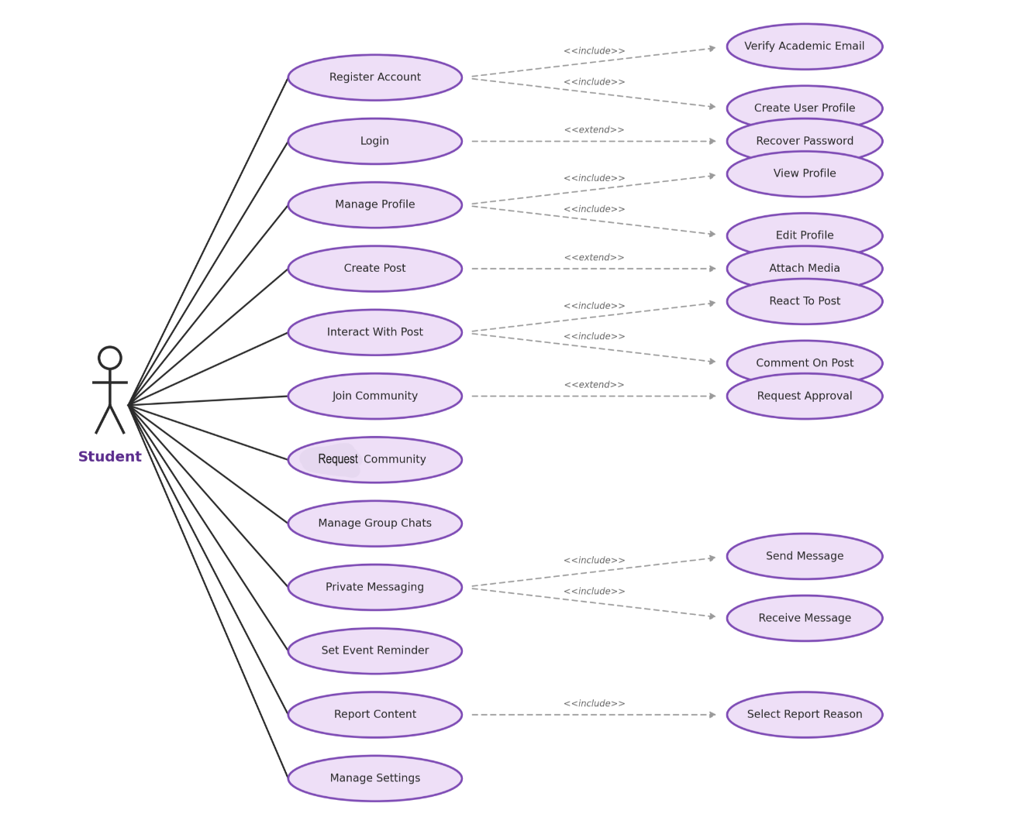

Figure ‎3.1 Student Use Case Diagram

Instructor

The instructor shares the student's actions and adds academic capabilities. As shown in Figure 3.2, an instructor can register and verify their academic email, manage their profile, create and interact with posts, and uniquely mark posts as academic to raise their priority in the feed. Instructors also manage academic group chats in addition to regular group chats, join and request communities, exchange messages, set event reminders, report content, and manage their settings.

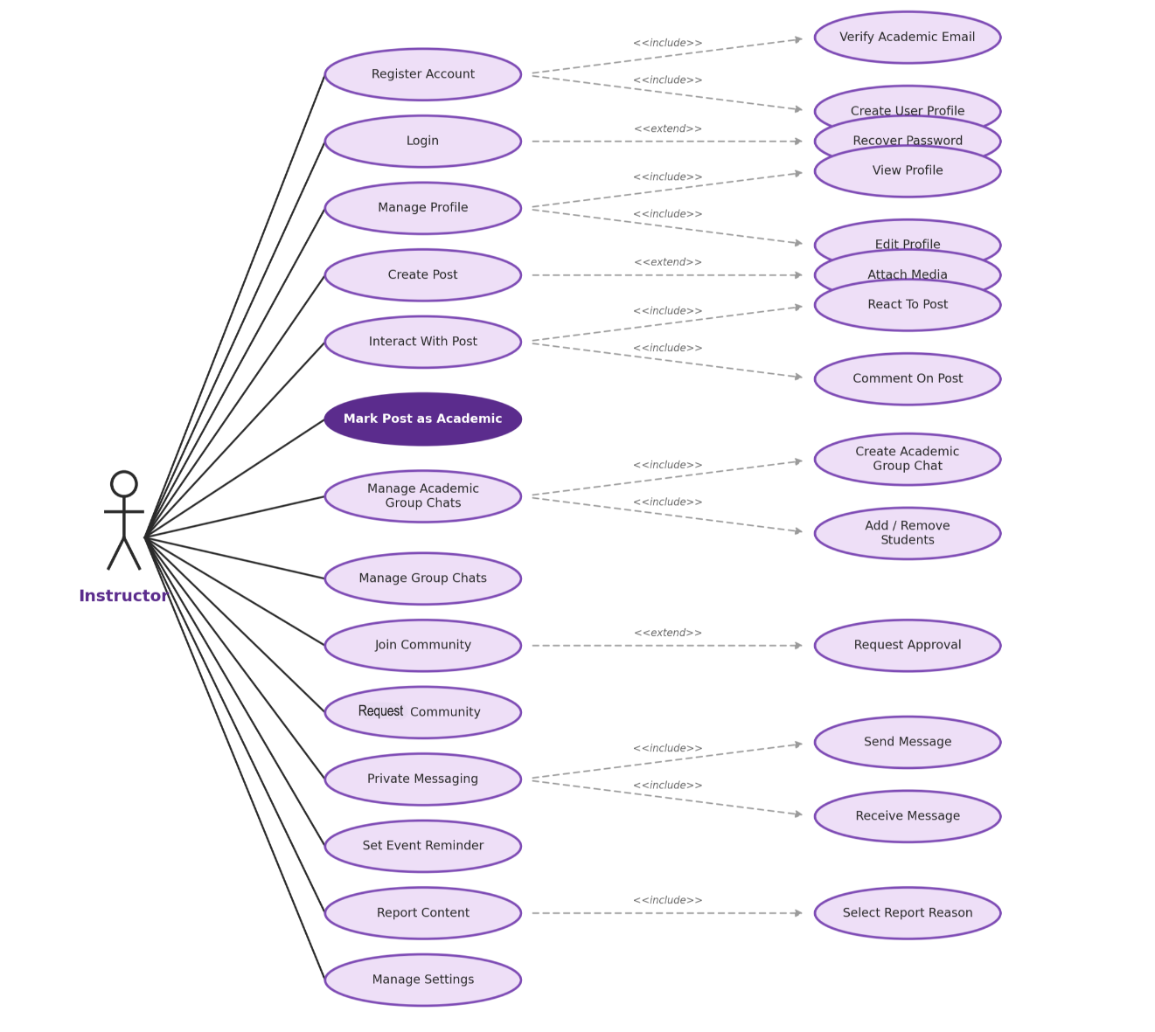

Figure ‎3.2 Instructor Use Case Diagram

Page

A page represents a business or collaborator on the platform. As shown in Figure 3.3, a page can log in and manage its page profile. As a subscriber-based account, it can subscribe to and manage a subscription plan and run promotion campaigns, which are central to its role. A page can also create posts, create and manage events, create and join communities, publish announcements, and manage its settings. Community creation depends on the subscription tier: Basic pages submit a request for review, while Premium pages create communities instantly.

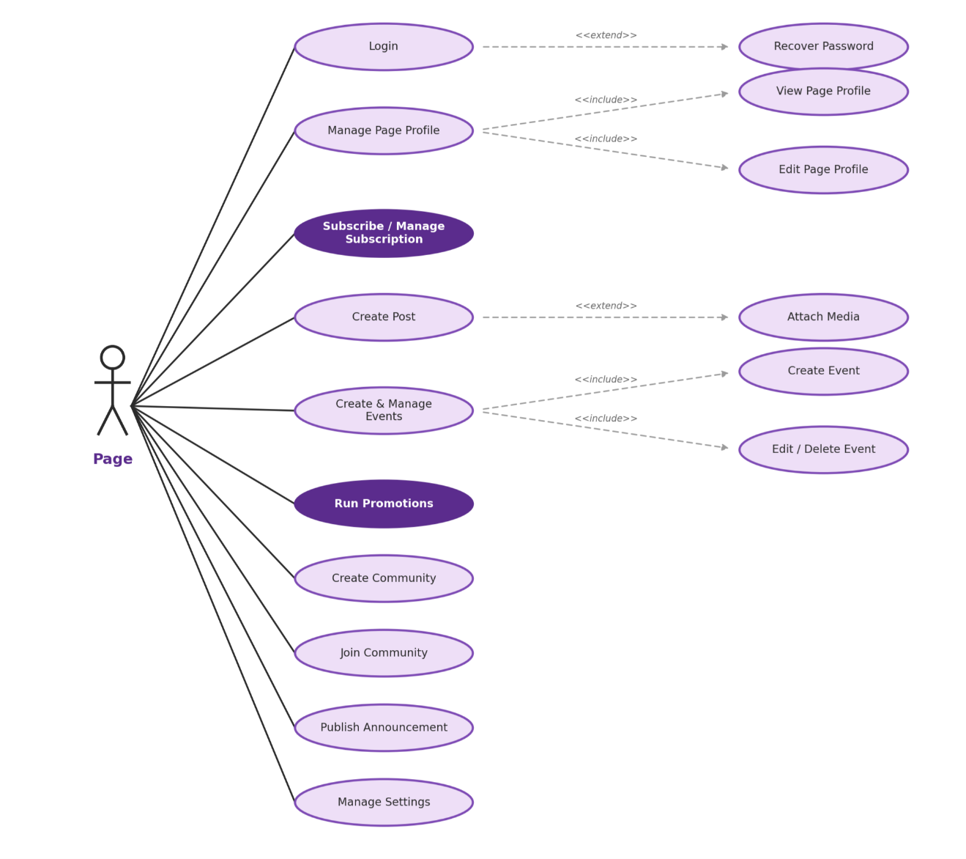

Figure ‎3.3 Page Use Case Diagram

University

A university operates as an enhanced page with exclusive institutional capabilities. As shown in Figure 3.4, a university can log in and manage its profile, and uniquely publish announcements that include setting a title and duration and appear in its Latest News. A university can also create and manage events, create communities instantly, join communities, create posts, and manage its settings. Its faculty directory is maintained automatically, as instructors are added to it when they register with the university's academic email.

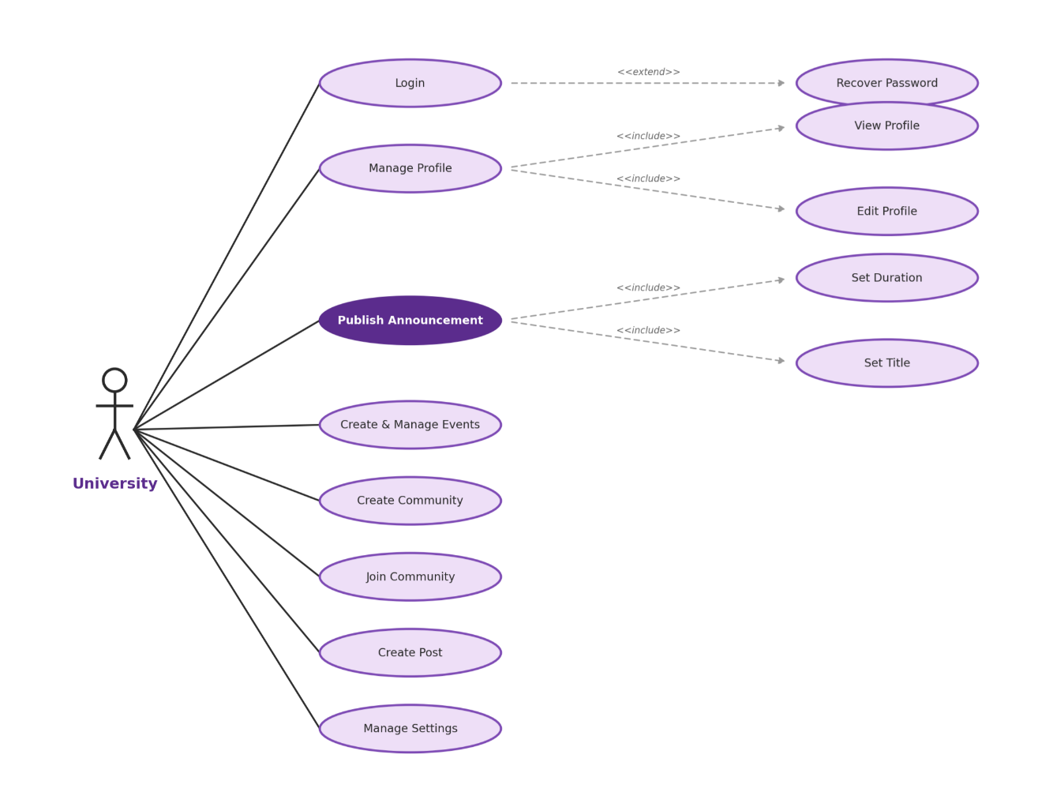

Figure ‎3.4 University Use Case Diagram

Admin

The admin operates the platform through a back-end control panel rather than the standard user interface. As shown in Figure 3.5, an admin can review community creation requests by approving or rejecting them, create page accounts, moderate reported content by reviewing reports and removing content, and suspend or ban users.

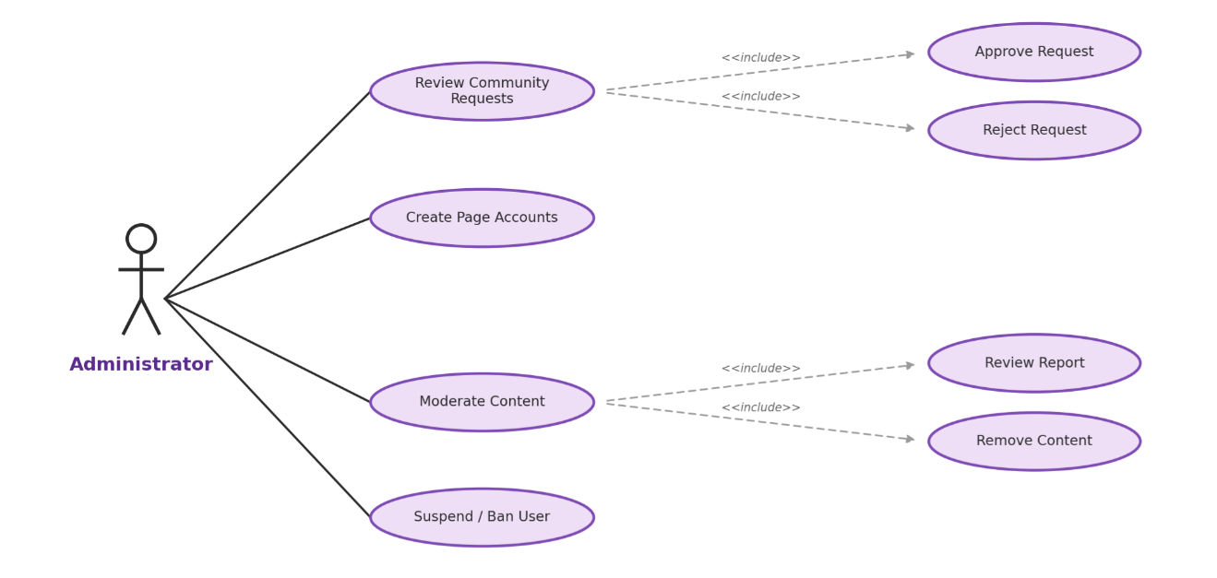

Figure ‎3.5 Admin Use Case Diagram

Sequence Diagrams

A sequence diagram shows how the parts of the system interact over time to carry out a specific process, illustrating the order of messages exchanged between the user, the interface, the back end, and the supporting services. This section presents sequence diagrams for the key processes of Project Campus.

User Registration

Figure 3.6 shows the registration process. The user begins by entering a username and academic email. The back end first checks that the academic email is valid: if it is not, registration is rejected. If the email is valid, the username and email are saved temporarily and a verification code is sent to the email. The user then enters the code, which the back end checks. If the code is correct, the academic email is verified and the user completes registration by setting a password and providing a personal email, after which the account is created. If the code is incorrect, an error is returned so the user can try again.

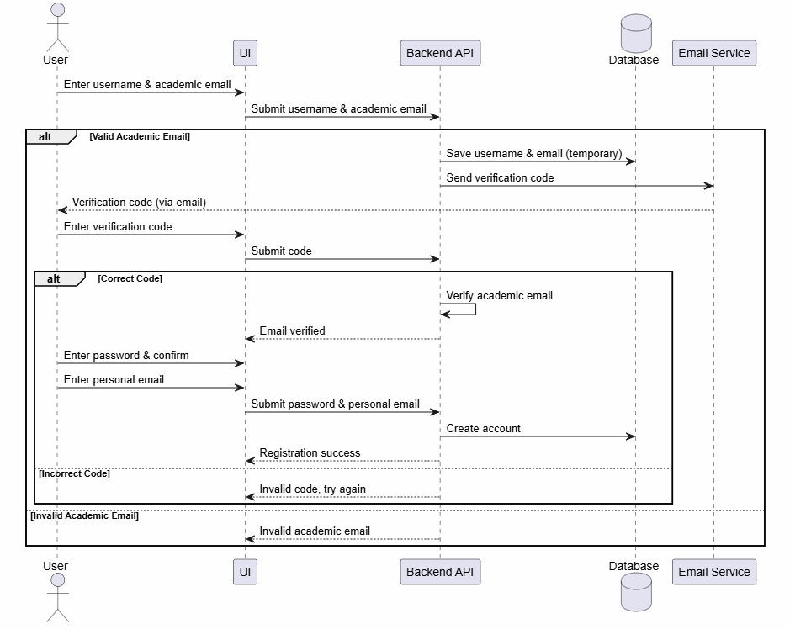

Figure ‎3.6 User Registration Sequence Diagram

Create Post

Figure 3.7 shows the process of creating a post. While creating, the user can optionally enter text, select one of their joined communities, mark the post as academic (available to instructors), and attach media. The post and any media are submitted together to the back end. If the post is directed to a community that requires approval, it is saved as pending and the user is notified once it is approved and published; otherwise, the post is saved and published immediately, and the relevant followers or community members are notified.

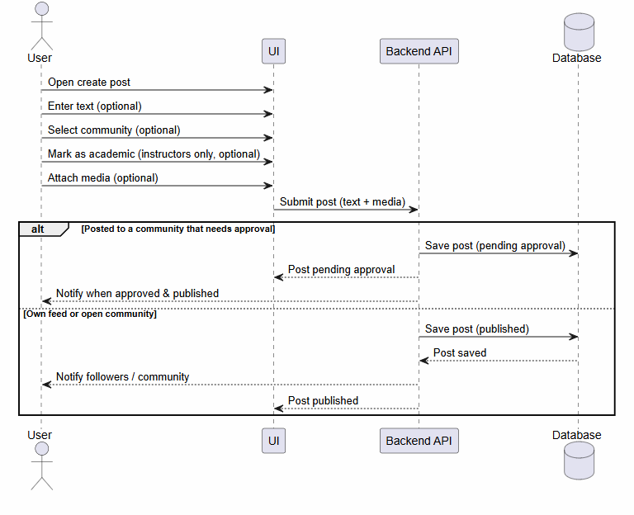

Figure ‎3.7 Create Post Sequence Diagram

Send Message

Figure 3.8 shows the messaging process. The user opens a chat and types a message, which can include text, photos, or videos. The message and any media are submitted together to the back end, saved to the database, and the recipient is notified, after which the message is delivered.

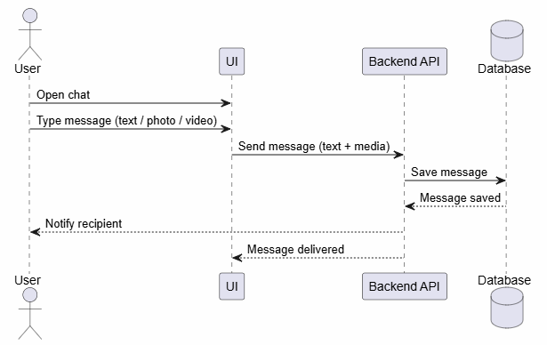

Figure ‎3.8 Send Message Sequence Diagram

Join Community

Figure 3.9 shows the process of joining a community. After the user requests to join, the back end checks the community type. If the community is public, the user is added immediately and the join succeeds. If the community is private, the request is saved and the user is placed in a waiting state pending approval.

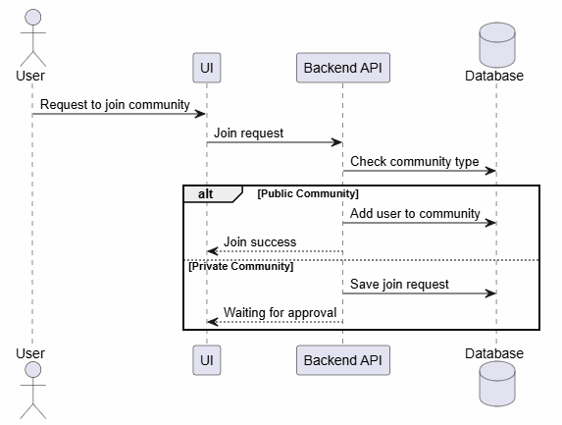

Figure ‎3.9 Join Community Sequence Diagram

Community Creation Request

Figure 3.10 shows how a community is requested and created. The user fills in a request form with the community’s name, description, and reason, and submits it. The request is saved in a pending state, and an admin later reviews it. If the request is approved, the community is created and the requester is notified; if it is rejected, the request is closed and the requester is notified.

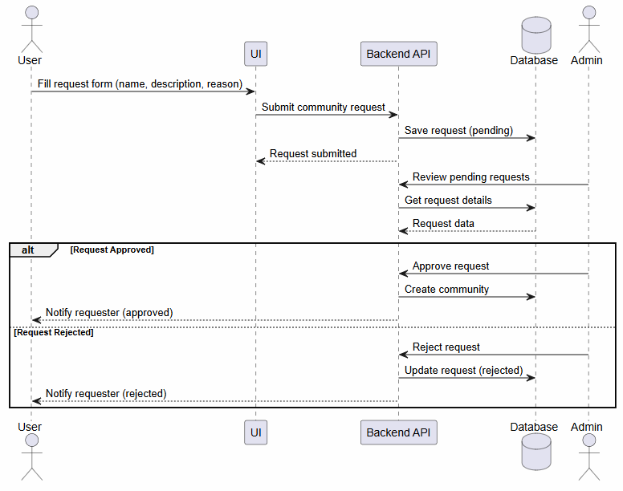

Figure ‎3.10 Community Creation Request Sequence Diagram

Subscription Checkout

Figure 3.11 shows the subscription process for a page. The page selects a plan, enters its card details in the checkout form, and submits the subscription. As this is a prototype without a real payment module, the subscription is then recorded as active and confirmed to the page.

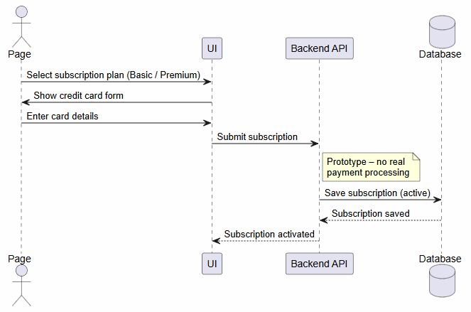

Figure ‎3.11 Subscription Checkout Sequence Diagram

Publish Announcement

Figure 3.12 shows how an announcement is published. When a university publishes an announcement, it sets a title and a duration; the announcement is saved, added to the university's Latest News, and its students are notified. When a page publishes an announcement, it is saved and the page's followers are notified. In both cases, the announcement is then published to the audience.

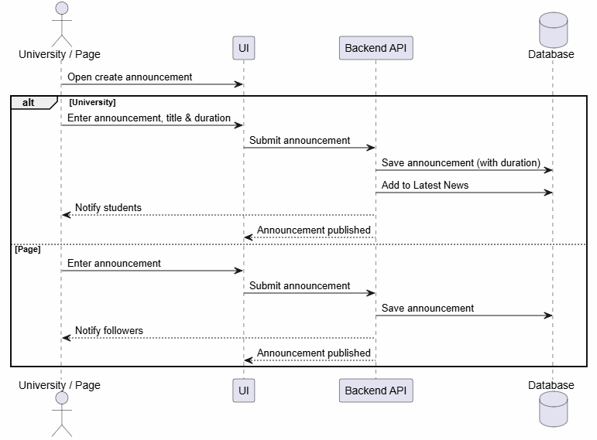

Figure ‎3.12 Publish Announcement Sequence Diagram

Entity Relationship Diagram

Presents the structure of the platform's database and the relationships between its entities. At its center is the user, which extends into role-specific records for students, instructors, admins, and pages, and links to the content it creates such as posts, comments, and messages. Pages connect further to subscriptions, events, and ratings, while the remaining entities covering communities, conversations, friendships, promotions, notifications, and reports capture the platform's social, organizational, and moderation features. Figure 3.13 shows the complete ERD.

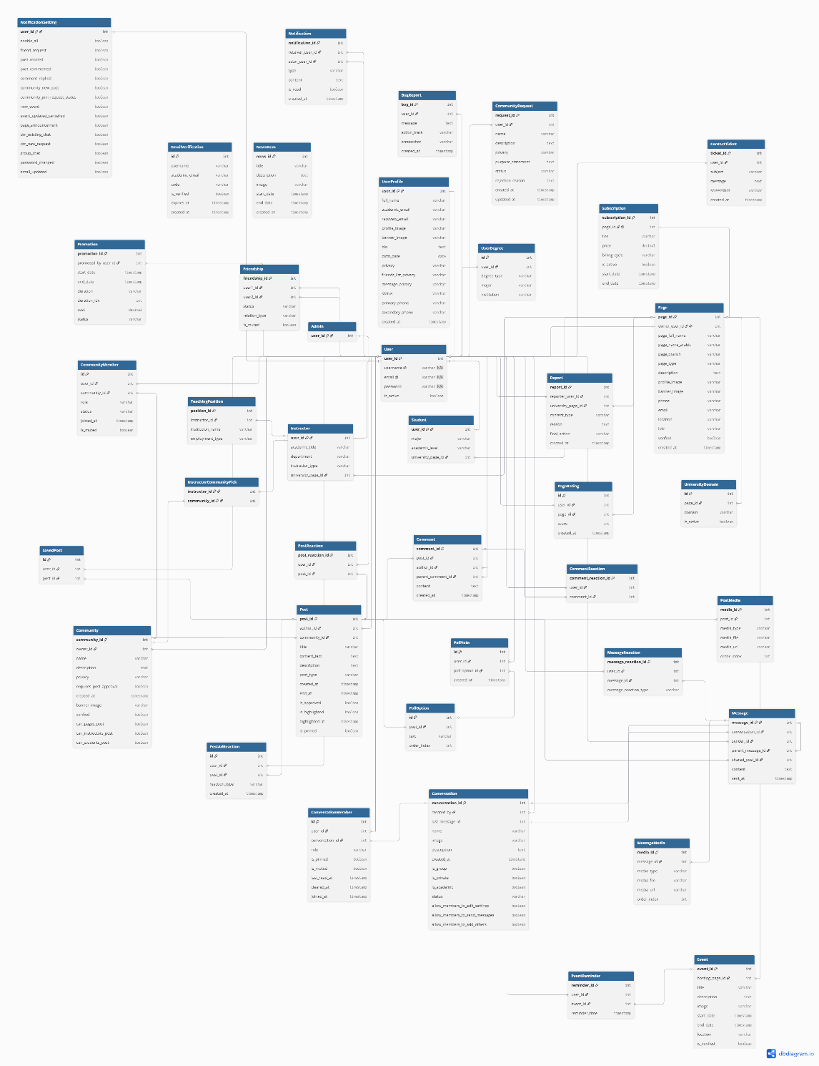
Figure ‎3.13 Entity Relationship Diagram

Database Tables

The platform's data is organized into a relational schema built on PostgreSQL. The tables are grouped by the area of the system they support user accounts and profiles, pages and subscriptions, communities, posts and interactions, messaging, events, relationships, announcements and notifications, and moderation and support. Table 3.8 summarizes the main database tables and the purpose of each.

Table ‎3.7 Database Tables
Table | Purpose | Key Fields
Users, Profiles & Roles
user | The core account for every user, holding login credentials and identity. | username, email, password (hashed), is_active
user_profile | Extended profile information and privacy settings for each user. | full_name, academic_email, recovery_email, bio, profile_image, privacy, status
user_degree | Academic degrees associated with a user. | degree_type, major, institution
email_verification | Temporary records used to verify academic emails during registration. | username, academic_email, code, is_verified, expires_at
student | Student-specific details linked to a user and their university. | university_page, major, academic_level
instructor | Instructor-specific details, linked to a user and their university. | academic_title, department, instructor_type, university_page
teaching_position | Teaching positions held by an instructor. | institution_name, employment_type
admin | Marks a user as a platform admin. | user
Pages, Subscriptions & Ratings
page | Business, collaborator, and university accounts. | page_full_name, page_type, description, verified, location
subscription | The subscription plan held by a page. | tier, price, billing_cycle, is_active, start_date, end_date
page_rating | User ratings for a page. | score (1-5)
university_domain | Academic email domains that map users to a university page. | domain, is_active
Communities
community | Interest-based communities and their settings. | name, description, privacy, requires_post_approval, verified
community_member | Membership records linking users to communities with roles. | role, status, joined_at
community_request | Requests to create a new community, pending admin review. | name, description, purpose_statement, status, rejection_reason
Posts & Interactions
post | Posts created by users, optionally within a community. | title, content_text, post_type, is_approved, is_highlighted, author, community
post_media | Media (image, video, file) attached to a post. | media_type, media_file, order_index
comment | Comments and replies on posts. | content, author, parent_comment
post_reaction | User reactions to posts. | post, user
comment_reaction | User reactions to comments. | comment, user
post_ad_reaction | User feedback on advertisement posts (good, neutral, or bad). | post, user, reaction_type
saved_post | Posts saved by a user. | user, post
poll_option | The options of a poll attached to a post. | post, text, order_index
poll_vote | A user's vote on a poll option (one vote per option). | option, user, created_at
Messaging
conversation | Direct chats and group chats, including academic group chats. | name, is_group, is_academic, status, created_by, last_message
conversation_member | Members of a conversation and their roles. | role, is_pinned, is_muted, last_read_at
message | Messages sent within a conversation. | content, sender, shared_post, parent_message, sent_at
message_media | Media attached to a message. | media_type, media_file, order_index
message_reaction | User reactions to messages. | message_reaction_type
Events
event | Events created by pages and universities. | title, description, start_date, end_date, location, is_verified
event_reminder | Reminders set by users for events. | event, user, reminder_time
Relationships
friendship | Connections between users and follows of pages and universities. | user1, user2, status, relation_type, is_muted
Announcements, Promotions & Notifications
news_item | Items shown in the Latest News section. | title, description, image, start_date, end_date
promotion | Promotion campaigns run on content such as events or communities. | duration, cost, status, start_date, end_date
notification | In-app notifications delivered to users. | type, content, is_read, receiver, actor
user_notification_setting | Per-user notification preferences by type. | enable_all, and per-type toggles
Moderation & Support
report | Reports submitted by users against content, and the action taken. | content_type, reason, final_action, reporter
contact_ticket | Support requests submitted by users. | subject, message, screenshot
bug_report | Bug reports submitted by users. | message, action_track, screenshot

Chapter Conclusion

This chapter presented a detailed analysis of Project Campus. It described the proposed system and its actors, defined their roles through a role-based access control model, and explained the membership, verification, and subscription mechanisms that govern how each actor operates. It then specified the system's functional and non-functional requirements and assessed the project's technical, economic, operational, and legal feasibility. Finally, it modeled the system's behavior and structure through use case and sequence diagrams, an entity relationship diagram, and a description of the database tables. Together, these establish a complete picture of what the system does and how its components relate, forming the foundation for the implementation described in the following chapter.

System Implementation

Introduction

This chapter describes how Project Campus was constructed. It begins with the implementation approach and the reasoning behind the chosen technologies, then presents the overall system architecture and its main components. Finally, it showcases the user interface of the platform across its different sections, illustrating how the design and functionality come together in the final product.

Implementation Approach

Before development began, the team defined a clear implementation approach covering the platform type, the technology stack, and the scope of the prototype.

Platform: Project Campus was implemented as a web-based platform, making it accessible across modern browsers without installation. A mobile application was intentionally placed outside the scope of this stage and is identified as future work.

Technology Stack: The platform was built using a modern, open-source stack chosen for its reliability, strong community support, and suitability for the project:

- Front end - React with Tailwind CSS: React provides a component-based interface that supports dynamic rendering and responsive design, while Tailwind CSS enables fast, consistent styling across the platform's many screens.

- Back end - Django with Django REST Framework: Django enables rapid development of secure, well-structured REST APIs and provides a built-in administration layer that supports the platform's behind-the-scenes management.

- Database - PostgreSQL: a reliable relational database that handles structured data and complex relationships and integrates seamlessly with Django's ORM.

User Verification: Students and instructors register using their academic email and confirm their identity through a verification code sent to that email, ensuring authenticity without requiring direct integration with university systems. Page and collaborator accounts are created by admins after direct contact.

Notifications: The platform delivers notifications through in-app alerts and email. Additional channels such as SMS and mobile push notifications are identified as future enhancements.

Scope: This stage delivers a functional prototype designed to operate within a single university, with the architecture prepared to expand to multiple institutions in the future. Deployment to a live production environment was outside the scope of the prototype.

System Architecture

Project Campus follows a three-tier architecture that separates the system into a presentation layer, an application layer, and a data layer, supported by a real-time layer for live features and an administrative layer for behind-the-scenes management. The overall structure and the way these layers interact are illustrated in the figure below.

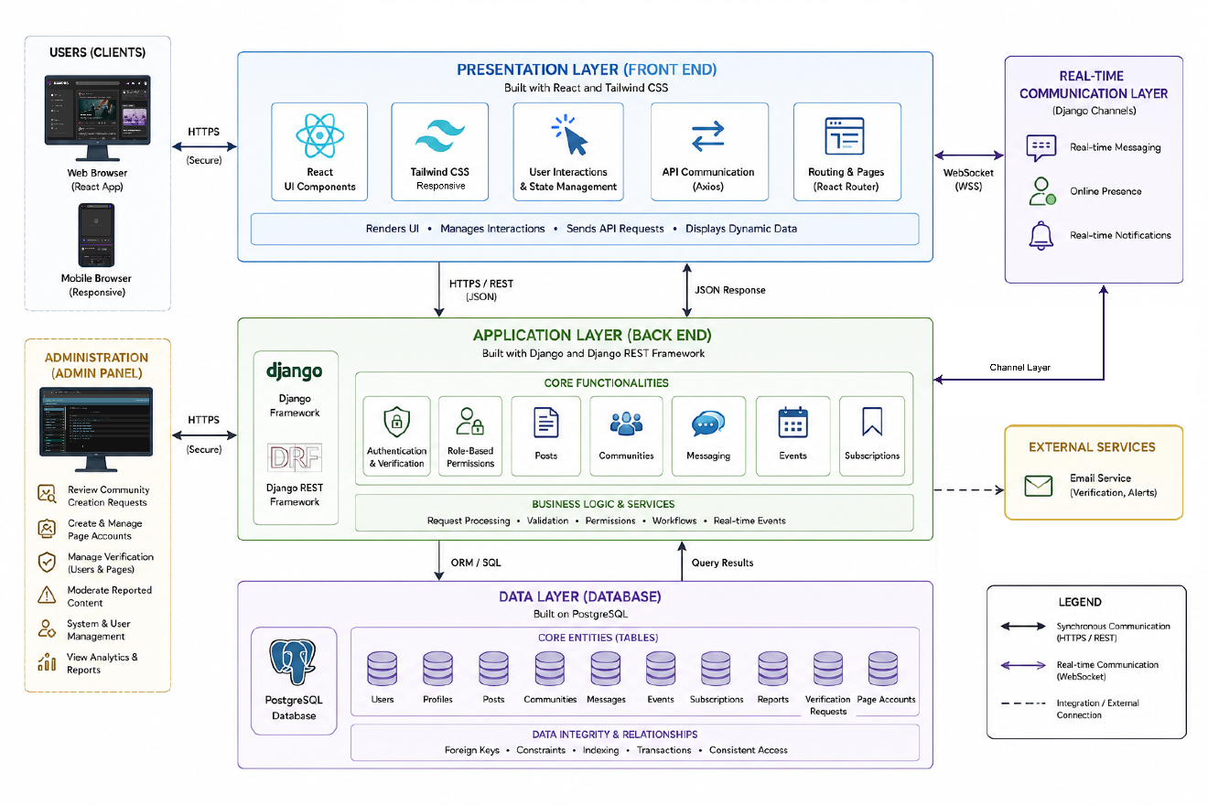

Figure ‎4.1 System Architecture

This architecture keeps the system organized and easy to maintain, and lets each layer be improved on its own without affecting the others. In a typical interaction, a user action in the React front end is sent to the Django back end, which checks authentication and permissions, then reads from or writes to the PostgreSQL database and returns the result. Real-time features such as messaging and online presence run through a separate real-time layer, while admins manage the platform through a back-end control panel instead of the normal user interface.

Table ‎4.1 Component table
Component | Technology | Role and Responsibilities
Front End | React + Tailwind CSS | Renders the user interface and handles all user interactions. Structures the platform's many screens into reusable components for a consistent look, and communicates with the back end to display and update data.
Back End | Django + Django REST Framework | Holds the core logic of the platform and exposes the APIs used by the front end. Handles registration, authentication, and verification, enforces each actor's role-based permissions, and manages posts, communities, messaging, events, subscriptions, and promotions.
Database | PostgreSQL | Stores all platform data, including users, profiles, posts, communities, messages, events, and subscriptions. Maintains the relationships between these entities and ensures data integrity and consistent access across the system.
Real-Time Layer | Real-time communication layer | Handles features that require instant updates, such as private and group messaging, online presence, and live notifications, allowing users to interact without refreshing the page.
Administration | Back-end control panel | Allows admins to manage the platform behind the scenes: reviewing community creation requests, creating page and collaborator accounts, and moderating reported content, without using the standard user interface.

User Interface

This section showcases the user interface of Project Campus across its main sections. The interface follows a consistent modern design with a dark theme and purple accents, applied uniformly across all roles and screens. Each of the following figures presents a key part of the platform.

Landing page and registration page

The landing page introduces the platform and directs visitors to register or log in. Students and instructors register using their academic email and confirm their identity through a verification code.

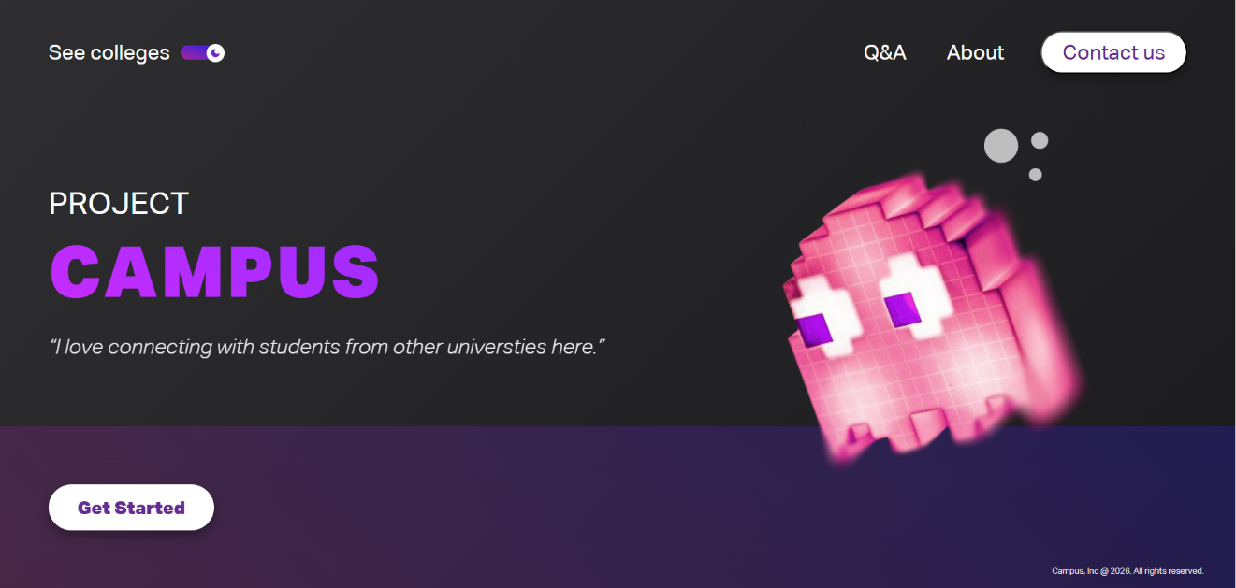

Figure ‎4.2 Landing page

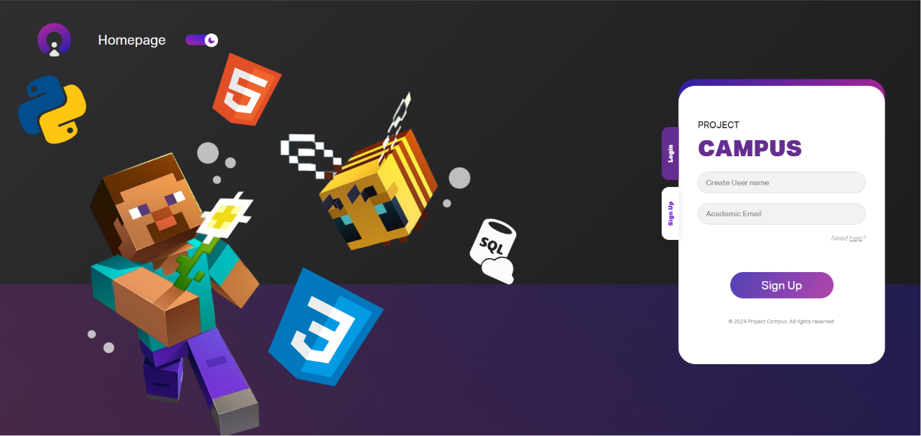

Figure ‎4.3 Registration page

Home Feed

The home feed is the central screen after login. It combines posts from friends, joined communities, followed pages, and the user's university, and surfaces recommended and trending content. It includes a post creation section supporting text, media, files, and polls, along with a weekly news panel.

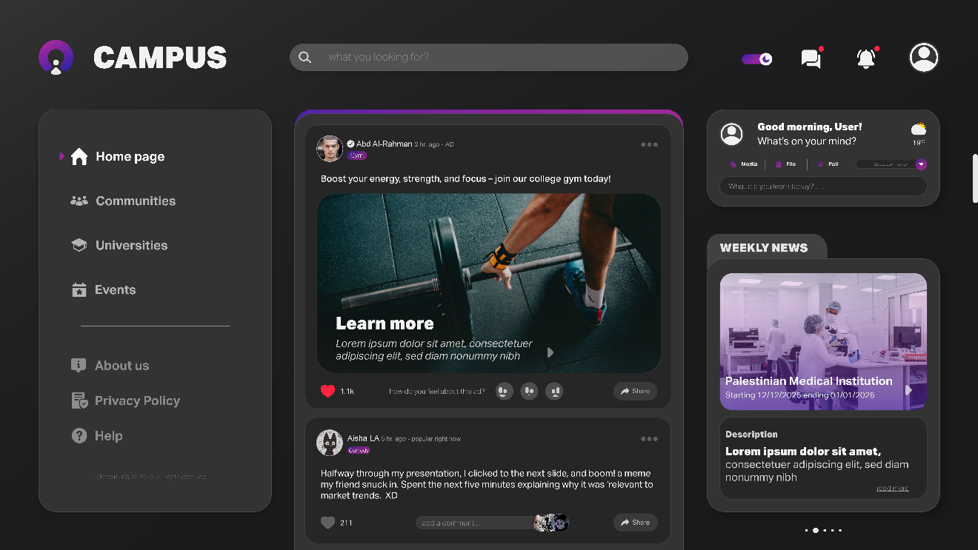

Figure ‎4.4 Home page

Profiles

Each role has a tailored profile. Student profiles display the university, major, friends, and interests; instructor profiles additionally show academic details, community picks and a distinct name color. Users edit their information through a dedicated edit page.

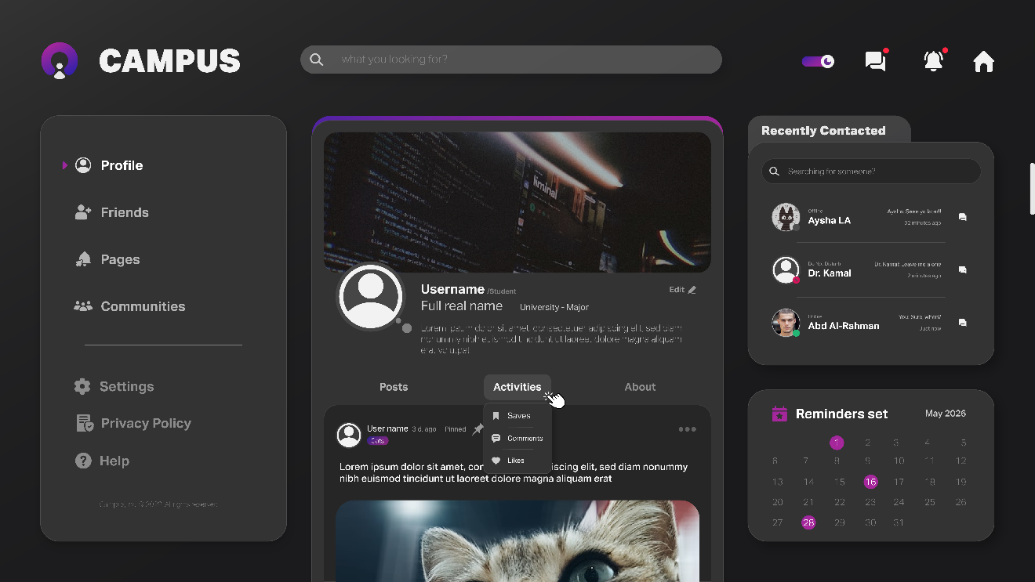

Figure ‎4.5 Personal profile

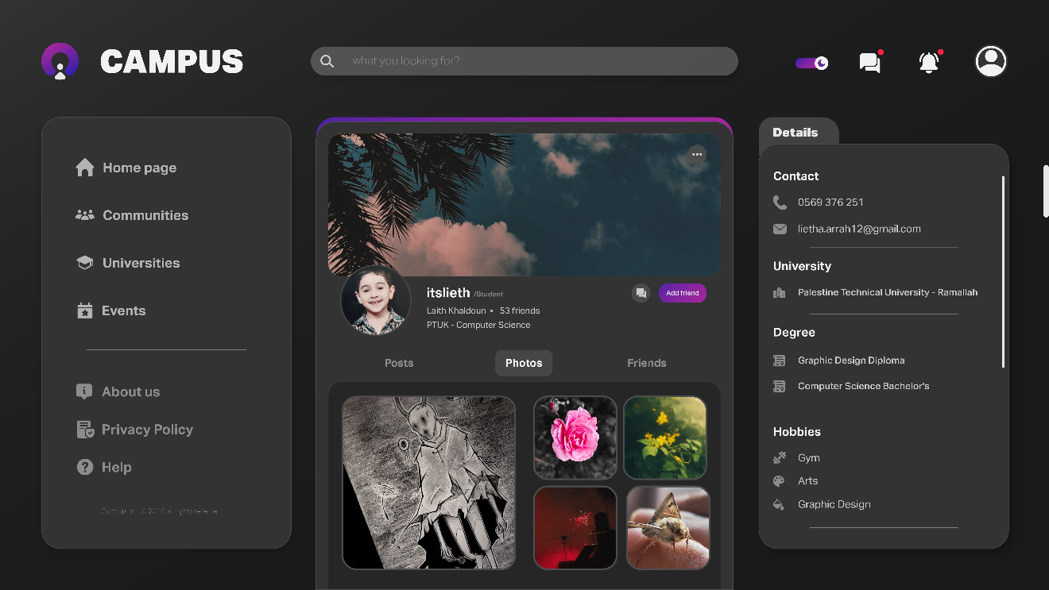

Figure ‎4.6 Student Profile
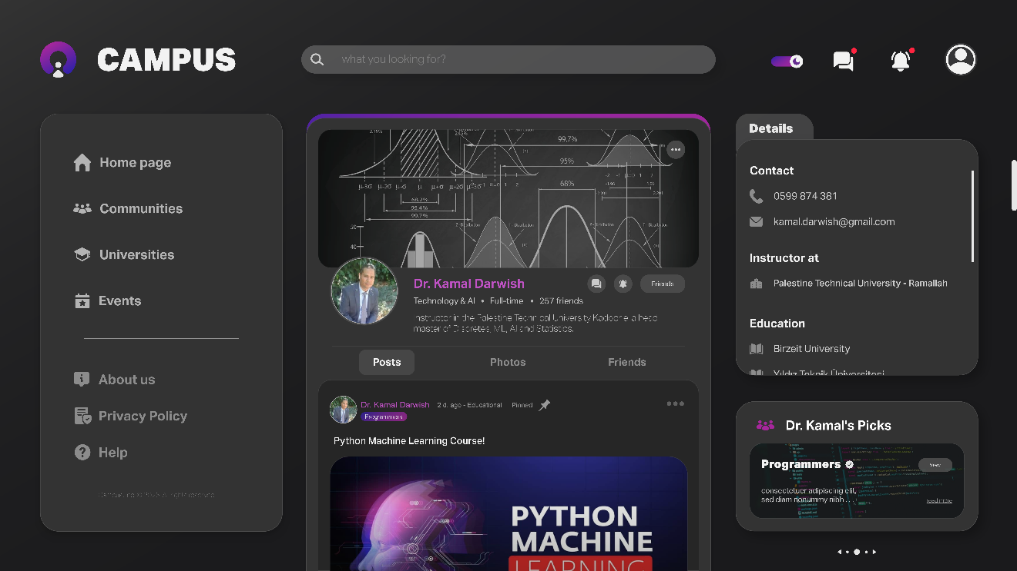

Figure ‎4.7 Instructor Profile

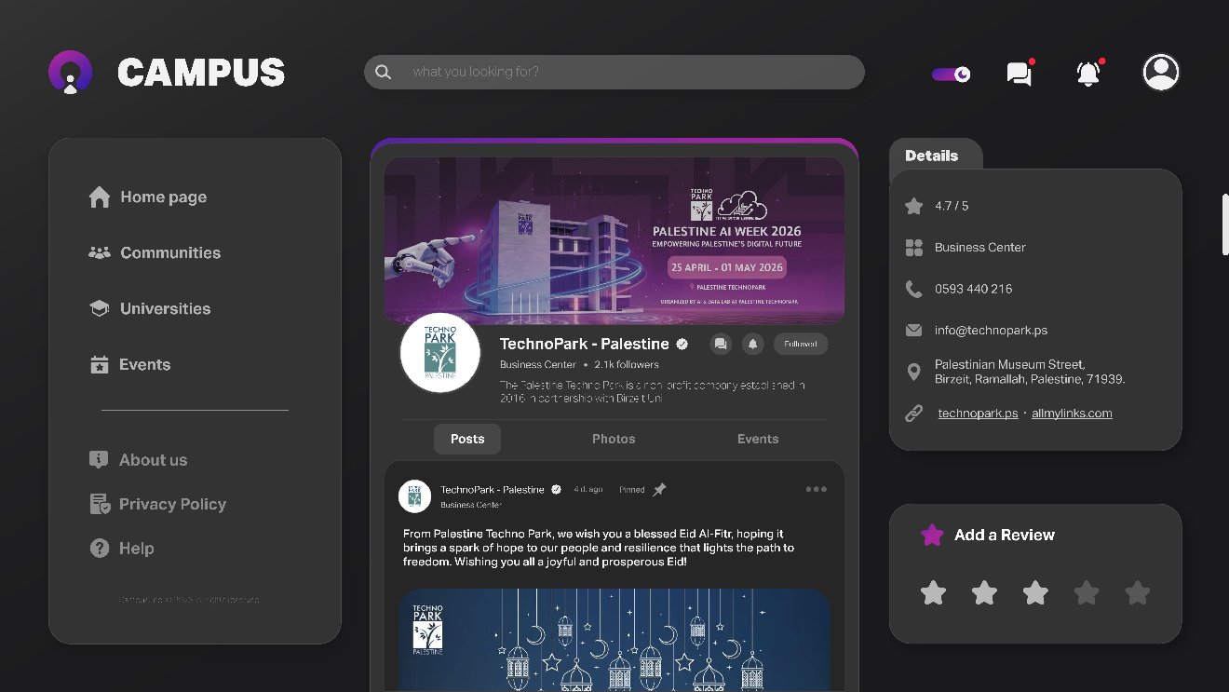

Figure ‎4.8 Page Profile

Communities

The communities section lets users discover and join communities, view inside a community, and for community admins manage members, requests, posts, approvals, reported posts, and highlights through a management panel.

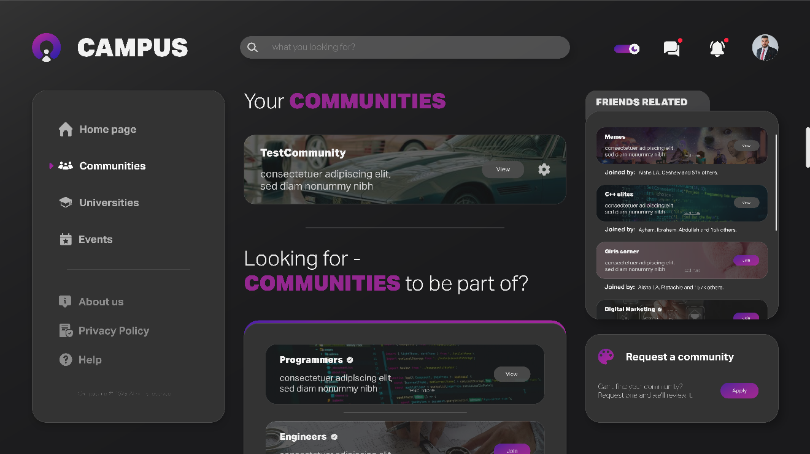

Figure ‎4.9 Communities Explore

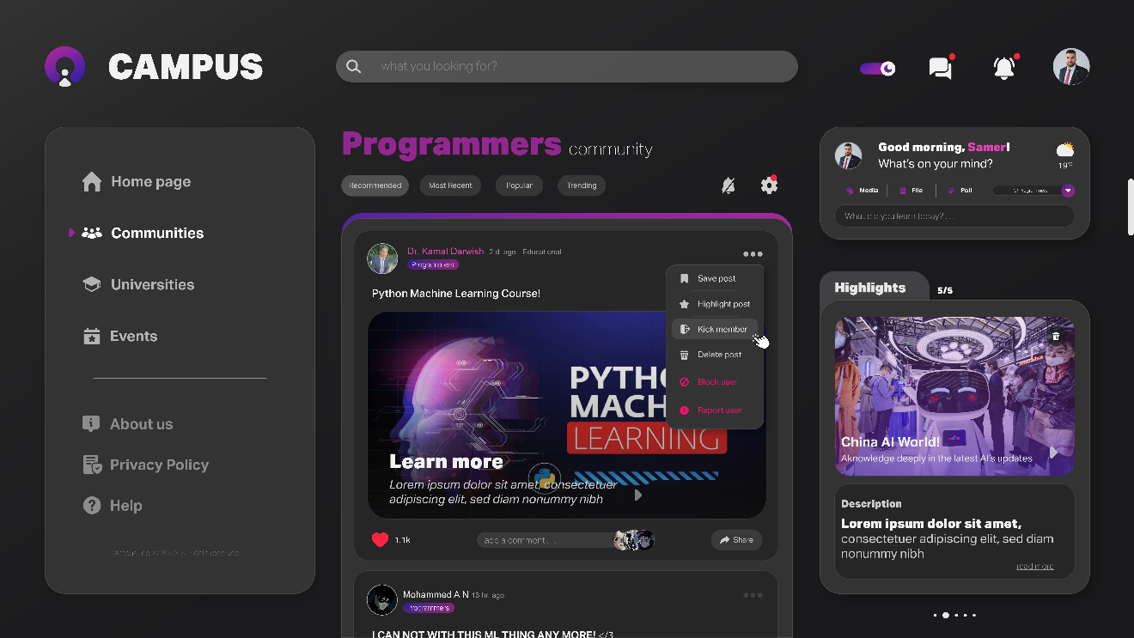

Figure ‎4.10 Community Feed

Chats and Group Chats

The chats section provides private messaging and group chats. It includes conversation filters, message requests, and per-chat actions, along with academic group chats managed by instructors and a group info panel for members, media, and permissions.

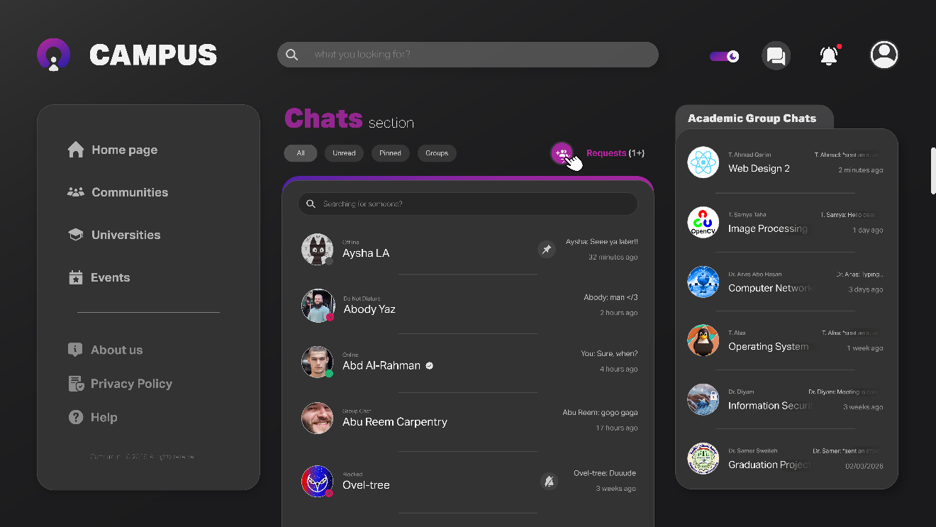

Figure ‎4.11 Chats Section

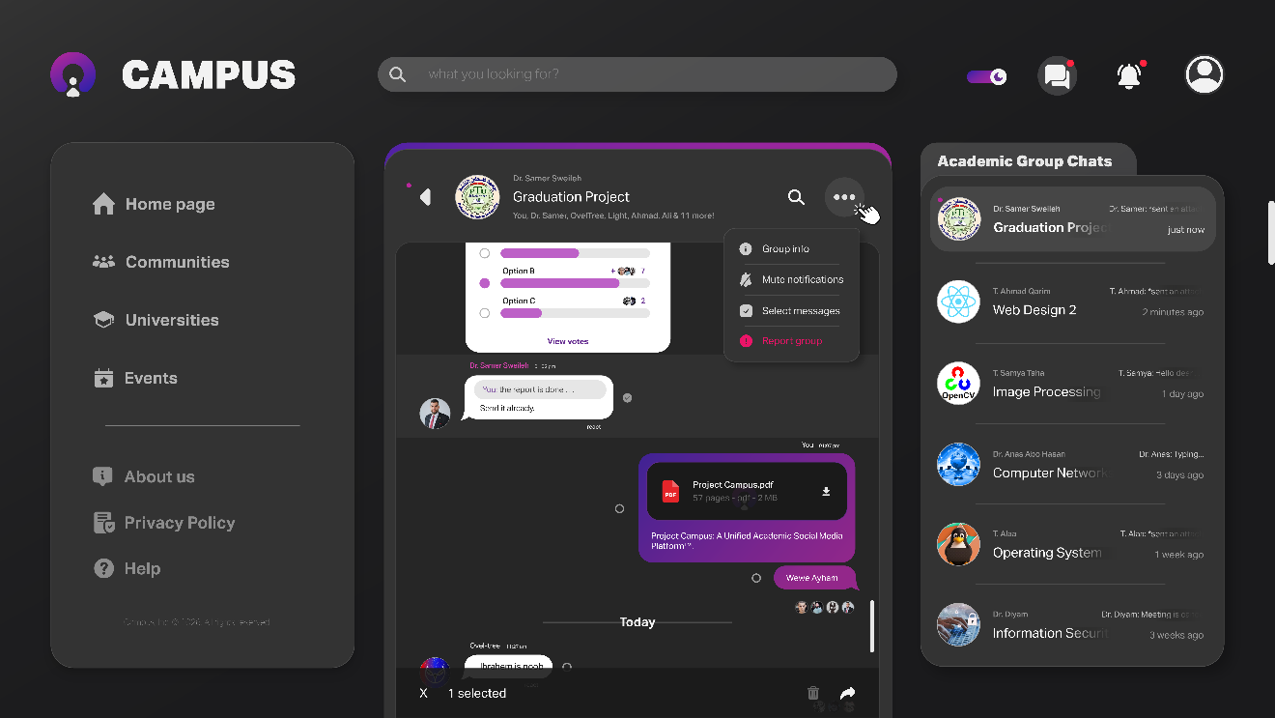

Figure ‎4.12 Academic Group Chat

University Page

The university page presents the institution with its official announcements in Latest News, a Doctors and Teachers directory, and related events. Universities manage their announcements through dedicated controls.

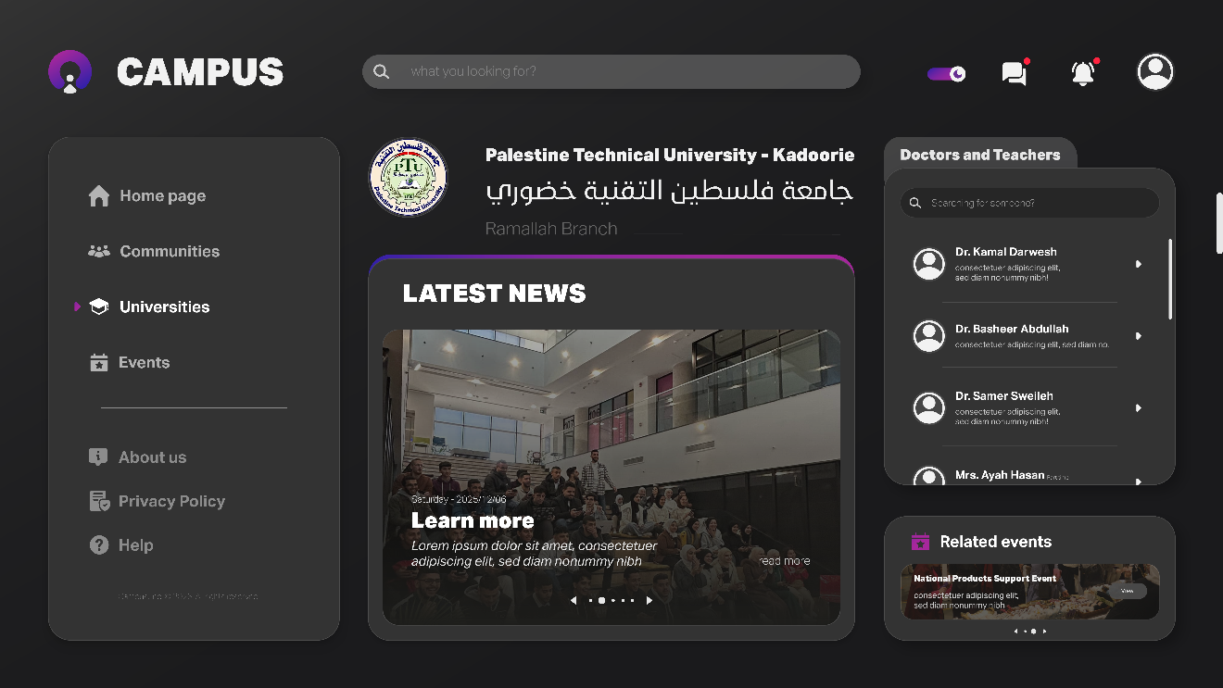

Figure ‎4.13 University Section

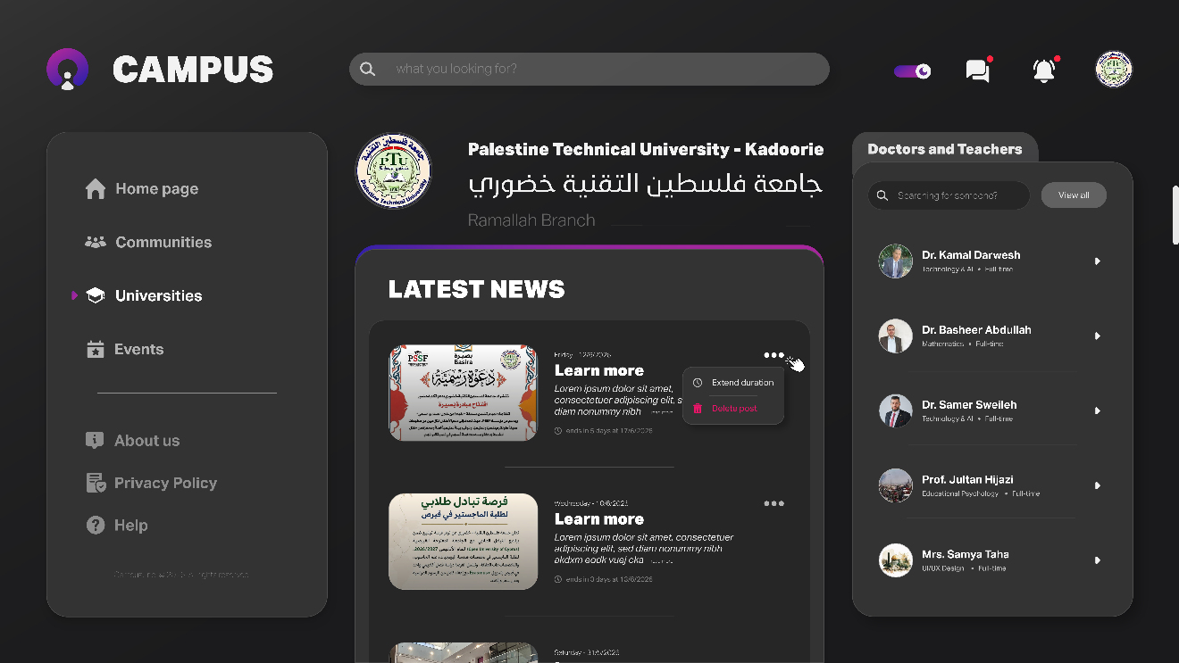

Figure ‎4.14 University Section Management

Events

Universities and pages create and manage events with duration control and promotion, while students discover, follow, and set reminders for them.

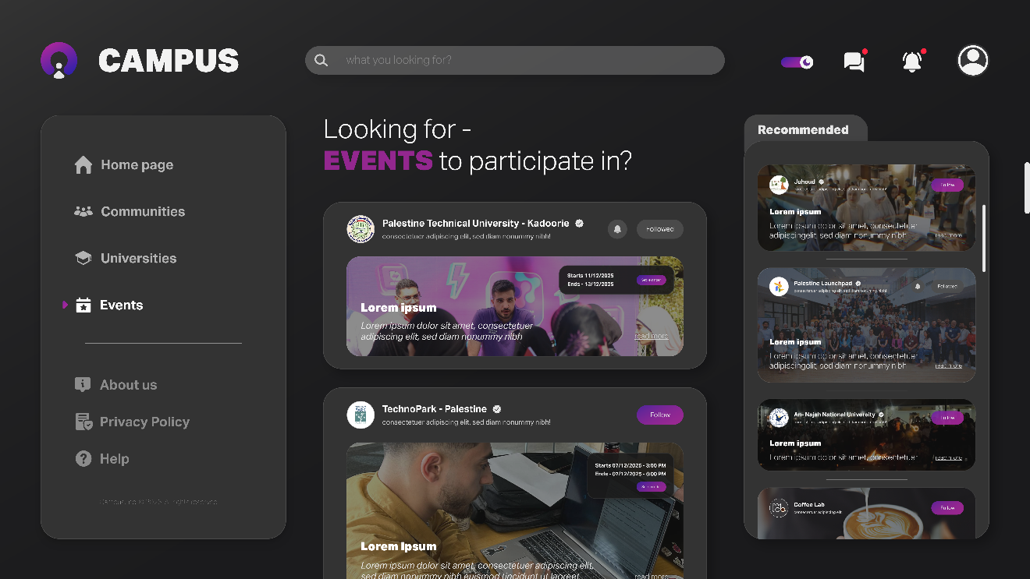

Figure ‎4.15 Events Section (Students and Instructors view)

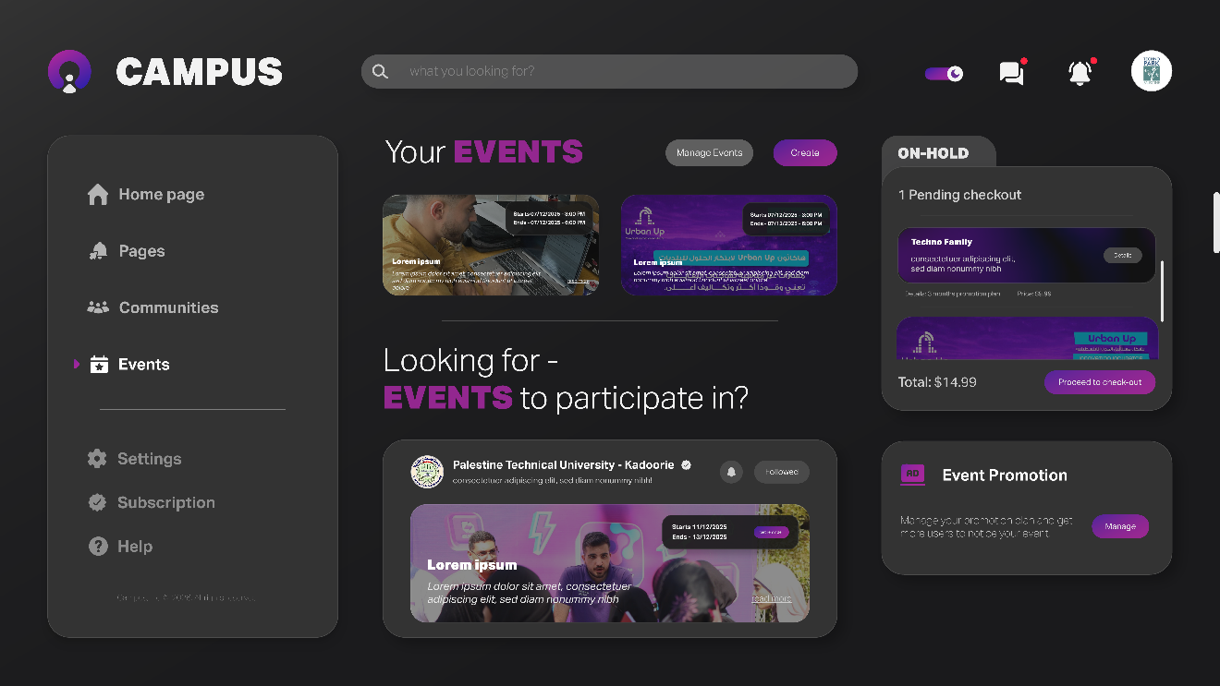

Figure ‎4.16 Events Section (Universities and Pages view)

Pages, Subscriptions and Promotions

Pages present a public profile with details, posts, and events. Page owners manage their subscription plan, create communities according to their plan, and run promotion campaigns through a checkout flow.

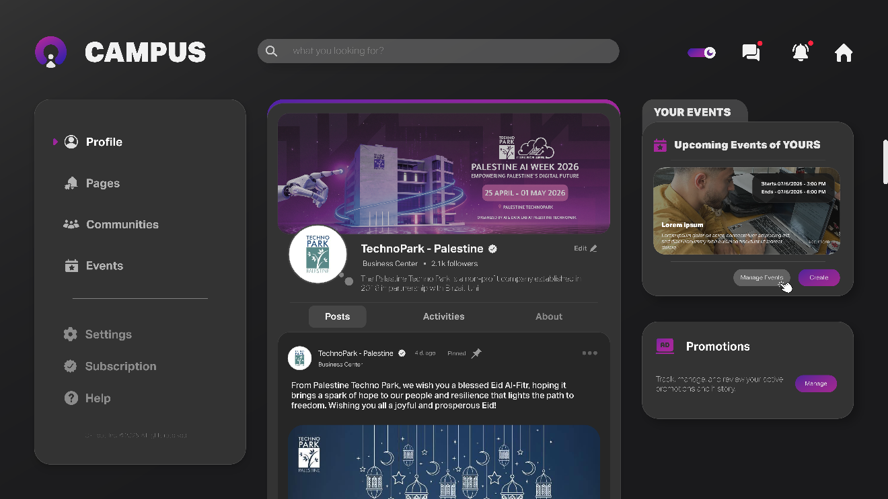

Figure ‎4.17 Page Personal Profile

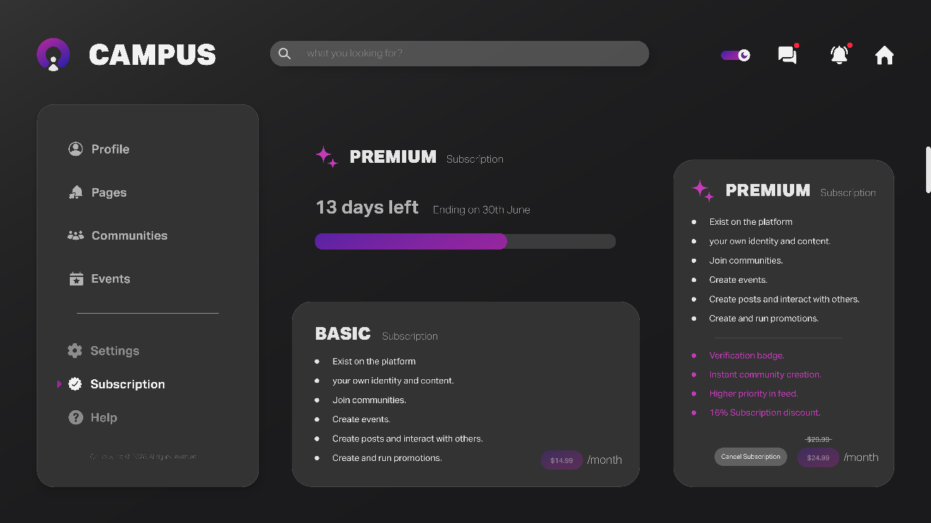

Figure ‎4.18 Subscriptions
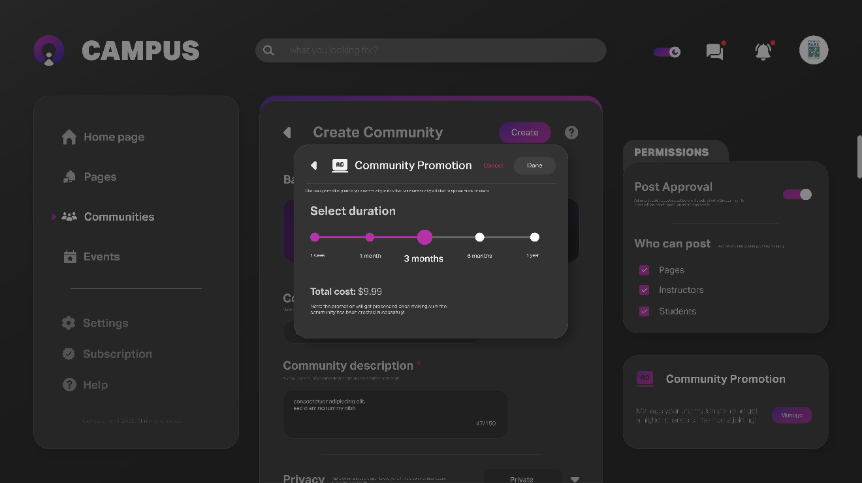

Figure ‎4.19 Community Promotion

Pages Section

The pages section helps users discover and follow business and collaborator pages. It presents recommended page, a list of the pages they already follow, and a feed of posts from those followed pages, keeping relevant updates in one place.

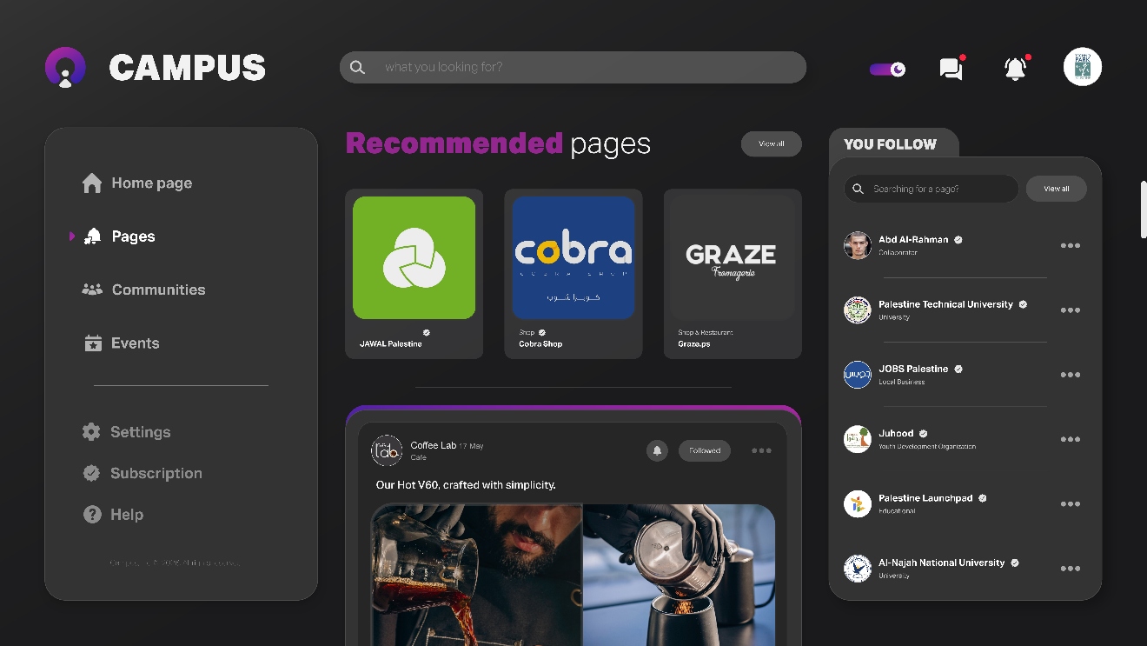

Figure ‎4.20 Pages Section

Chapter Conclusion

This chapter described how Project Campus was implemented. It presented the implementation approach and the technologies chosen for the platform, explained the three-tier system architecture and the role of each component, and showcased the user interface across the platform's main sections. Together, these demonstrate how the system's design and functionality come together in the final product. The following chapter concludes the project, reflecting on the challenges faced and outlining directions for future work.

Conclusion and Future-Work

Conclusion

Project Campus set out to solve a real and everyday problem in university life: the fragmentation of academic communication across informal and unreliable channels such as WhatsApp groups and Facebook pages. The project delivers a unified academic social platform that brings students, instructors, universities, and businesses together in a single, verified environment, where each actor operates through a clearly defined role.

Throughout the project, the team produced a complete design covering every user role, a documented system analysis including requirements and a role-based access model, a realistic and sustainable business model, and a functional prototype built on React, Tailwind CSS, Django, and PostgreSQL. The platform centralizes academic information, organizes academic and social interaction, and provides verified identities that strengthen trust and credibility within the university community.

By unifying communication, collaboration, and verified information in one place, Project Campus demonstrates both the feasibility and the value of replacing scattered tools with a single platform built specifically for the academic environment.

Challenges and Obstacles

Like any project of this scale, Project Campus faced a number of challenges throughout its development:

- Small team and broad scope: a team of three covered product design, frontend development, backend development, documentation, and testing for a platform spanning five user roles. This required careful prioritization and a clearly defined prototype scope to keep the work achievable.

- Large workload per member: with only three members, each person single-handedly owned an entire domain the full design, the complete frontend, and the entire backend. Each had to be built incrementally and in parallel rather than as one finished phase.

- Technical complexity: features such as real-time messaging, role-based access across multiple user types, and the subscription and promotion system each added significant depth to the implementation and required careful planning and integration.

- Evolving product decisions: several decisions such as community creation policies, moderation rules, and subscription pricing required multiple rounds of refinement to balance openness, content quality, and the realities of the local market.

- Time and resource constraints: the project was carried out alongside full academic coursework and without external funding, which limited the available time and restricted the team to free and open-source tools.

Future-Work and Recommendations

Project Campus, in its current form, delivers a functional prototype that establishes a strong foundation for future growth. Several directions are planned to expand and enhance the platform:

- Mobile applications: native iOS and Android applications to make the platform more accessible and convenient for students on the go.

- Third-party authentication: integration of options such as Google sign-in to simplify and speed up the registration process.

- Multi-university expansion: onboarding additional universities and enabling richer interaction between students across different institutions.

- AI-assisted academic tools: an integrated assistant to help with academic questions and smart content recommendations based on user interests and activity.

- Social Credits system: a reputation system that recognizes positive contribution and engagement within the community.

- Advanced analytics: richer dashboards for universities and pages, covering reach, engagement, and growth.

- Bilingual support: full English and Arabic interface support with right-to-left layout, adapting the platform to the local academic environment.

